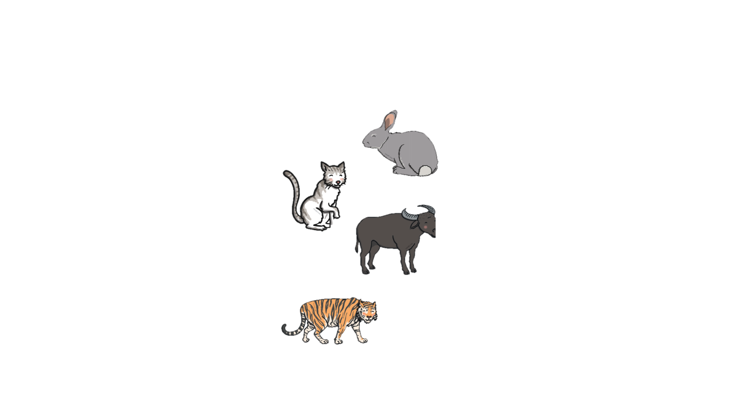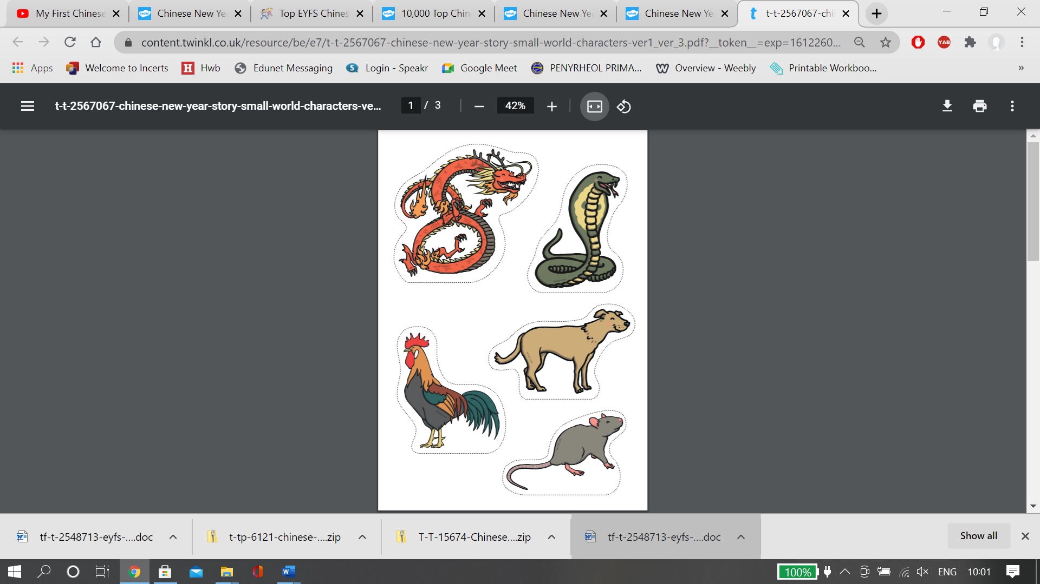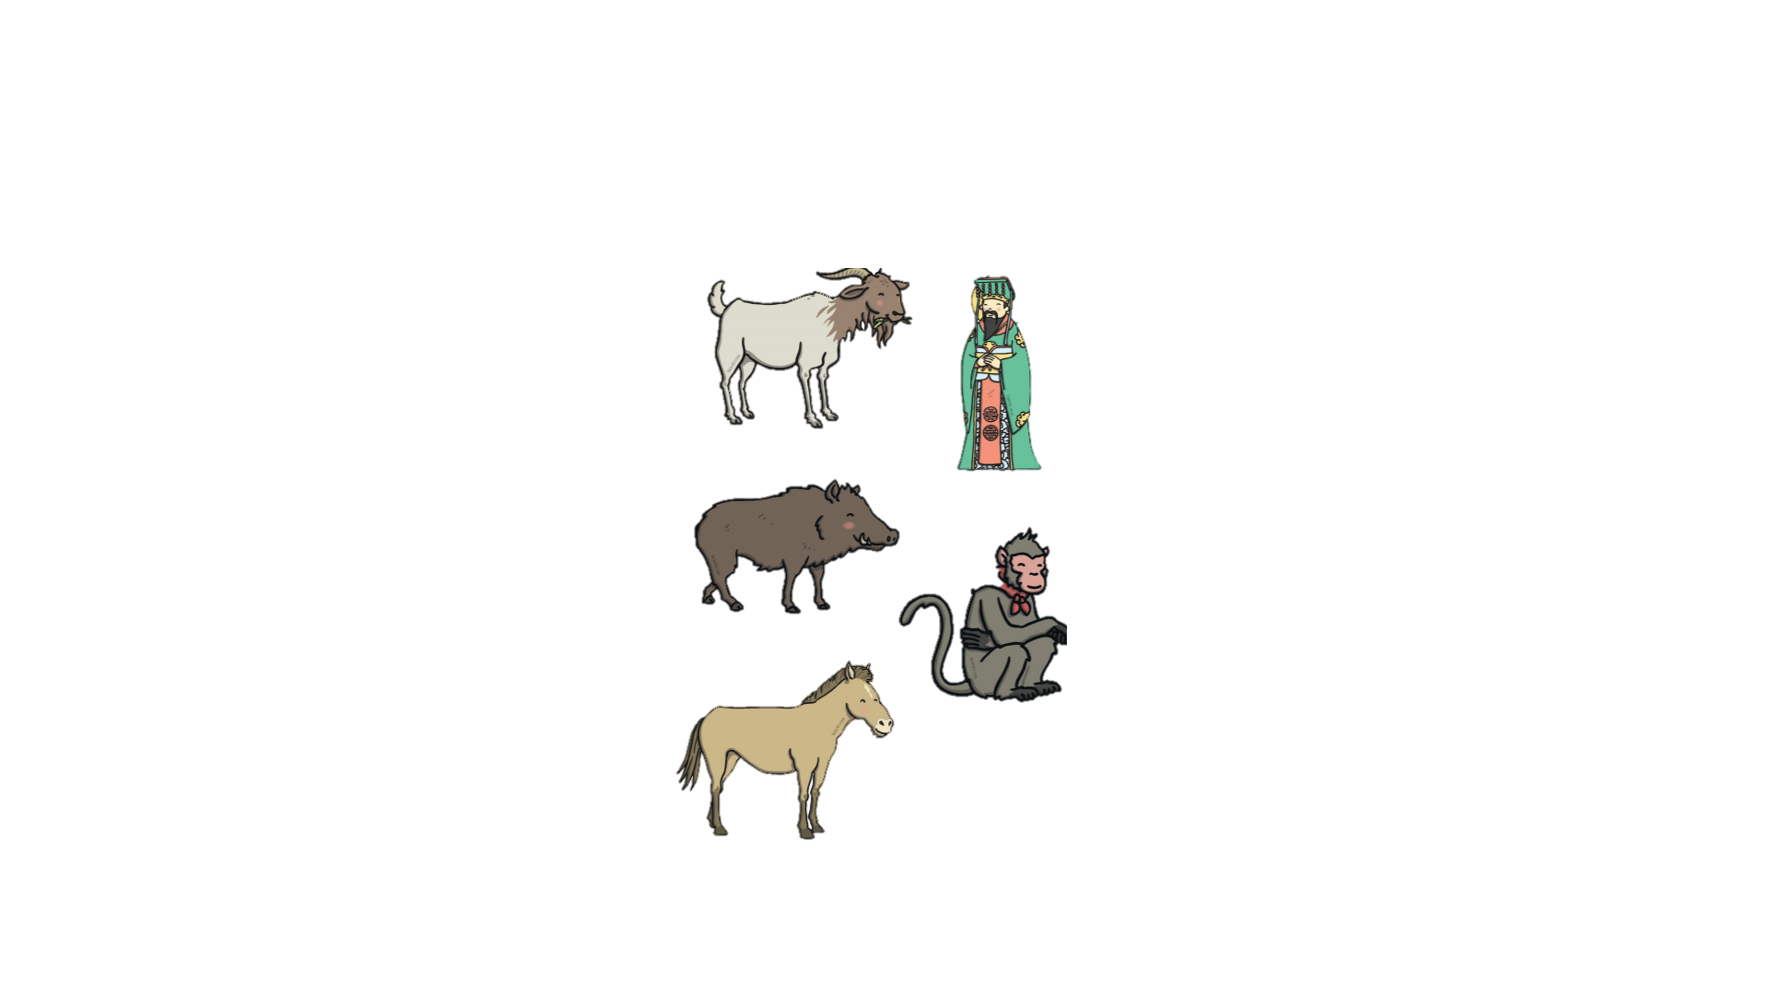

Guess the Animal. Cut out these Chinese New Year Story Small World Characters and place them into a bag.

Take it in turns to choose an animal. Act out being the animal and their family have to guess which animal they are.

Say what animals they are and why they like being that animal. i.e. I am a rabbit I love to hop!

**Guess the Animal**