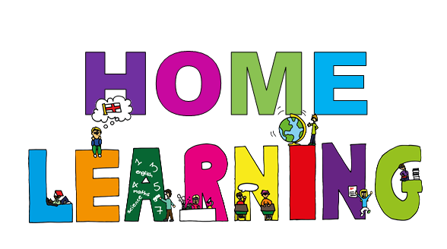

Monday 20th April Dydd LLun 20 Ebrill
Hello everyone! Bore da bawb.

Here are your learning activities to complete this week. Please send completed work to me via email, jamesr100@hwbcymru.net of share using hwb.

English
- Write an acrostic poem
Dragon
Castle
- Record your poem on J2e5 on hwb, or write it out and take a photo. If possible, share your poem with me via hwb or email, jamesr100@hwbcymru.net
Here is my acrostic poem:

Deadly animal
Roaring fiercely
Against his enemy.
Grazed and hurt he
Overcame the white dragon
Now stands proud on our flag.
- Spelling
Individual work shared via hwb

- Handwriting
Remember the boat and the sun – individual work shared via hwb.
Maths
- Continue practising your timetables and learning to tell the time.
- Estimating and rounding numbers – please see my maths for your work
https://www.bbc.co.uk/bitesize/topics/zh8dmp3/articles/zpx2qty video to explain how to estimate and round
https://www.bbc.co.uk/bitesize/topics/zh8dmp3/articles/zsvt97h video to explain rounding decimals

Exercise
https://www.youtube.com/user/mosetsanagape/videos strut your dance moves with Oti Mabuse. She will teach you a new dance routine every day.
https://www.youtube.com/user/thebodycoach1/videos workout with Joe wicks
Maybe get someone to film your dance routine or fitness work out to share with your friends.
How about you make your own video for your friends, you could do a fitness work out or a dance routine for your friends. If you share the video with me, I will upload to our class page for your friends (and me) to do.

Topic work
Label parts of a castle. This work has been shared on your Hwb account to be done in J2e5.
You will need to research the parts of a castle then complete the sheet in your shared files.
Time capsule
You are currently living through history. I have attached a document ‘Time capsule’ for you to print off (if you can) otherwise use it to help you make your own. You and your family can do this activity. Create a time capsule of key pieces of information to put into a box, which will be opened in years to come. You can included actual objects, pictures of family, pets, and drawings. Anything you would like to include.
Please send me a photo your time capsule.

Art
Look at Welsh artist, Gayle Rogers and create your own piece of art of a castle of your choice. Take a photo and share with me.
https://www.google.com/search?q=gayle+rogers+art+castle&tbm=isch&ved=2ahUKEwjw_5WG3MroAhWz5OAKHVRjALQQ2-cCegQIABAA&oq=gayle+rogers+art+castle&gs_lcp=CgNpbWcQAzoECAAQHlCvsAVYo7sFYNrCBWgAcAB4AIABfogB_ASSAQM1LjKYAQCgAQGqAQtnd3Mtd2l6LWltZw&sclient=img&ei=iV2GXrCXJ7PJgwfUxoGgCw&rlz=1C1GGRV_enGB813GB813
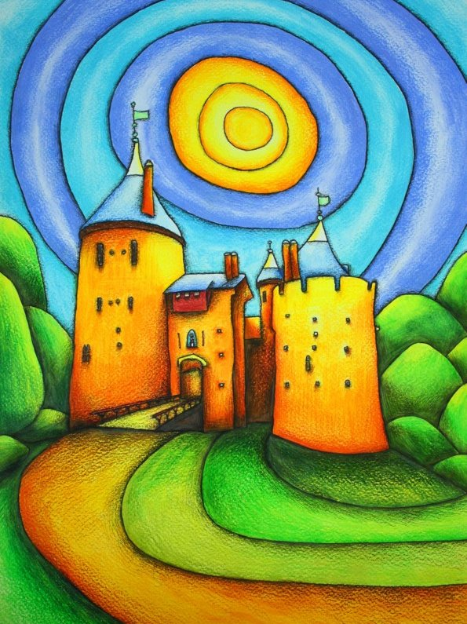
http://www.gaylerogersart.com/
Below are a couple of examples of her work.
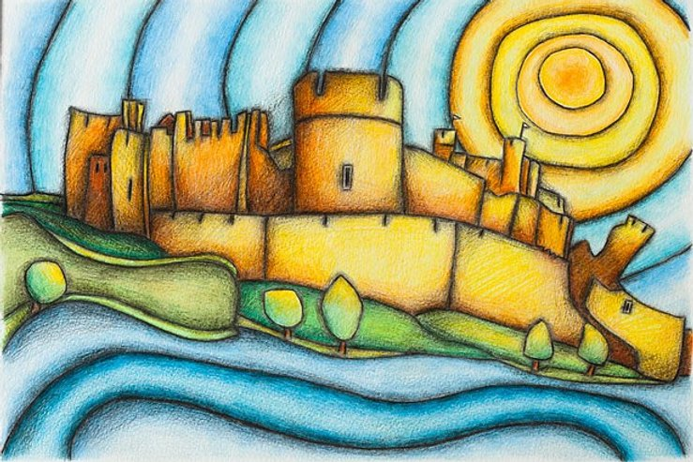
Caerphilly Castle
Castell Coch

