How did Stick Man feel?
Scared
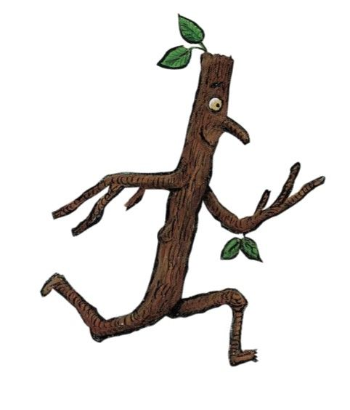
Find parts of the story to match the different emotions.
Happy

Lonely
Worried

Excited

