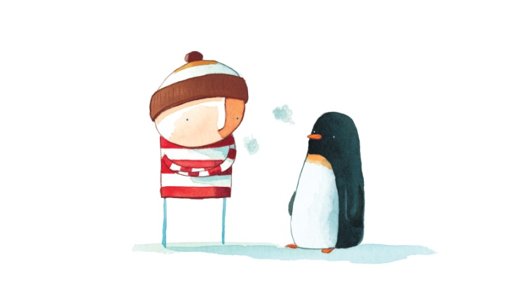

sad

lonely

How did the penguin feel when he arrived at the boy’s house?

*Complete the bubbles*