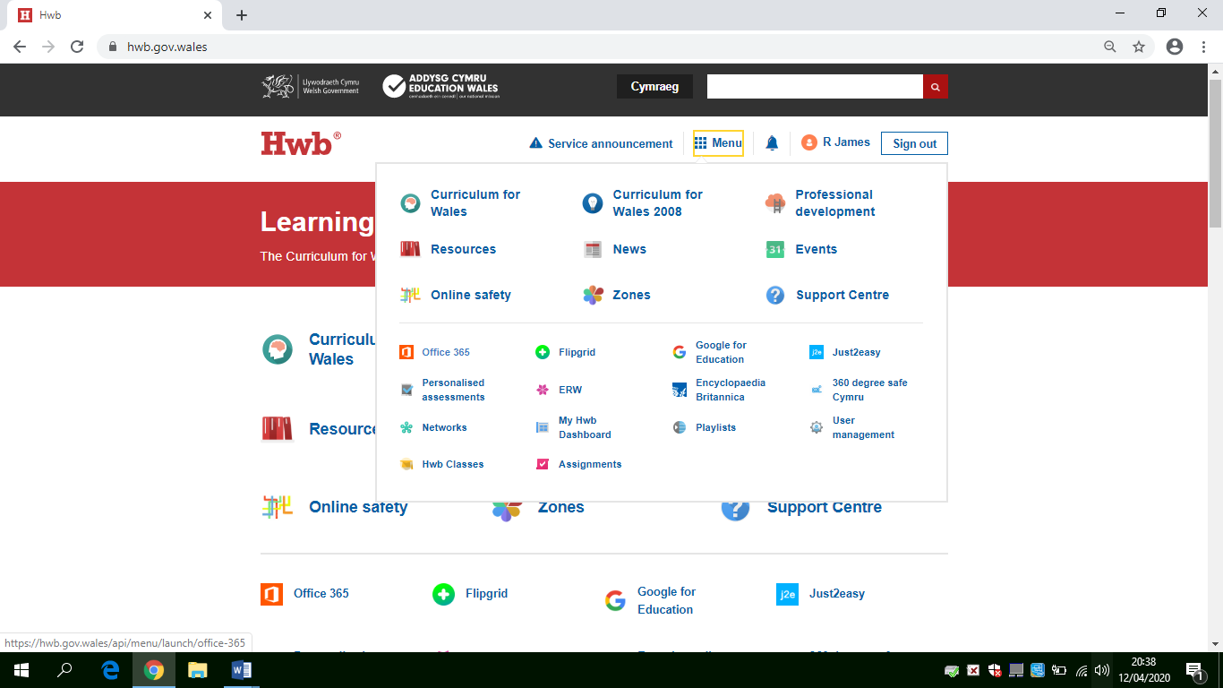
How to check your emails.
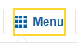
- Log on to Hwb
- Click menu

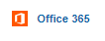
- The click on Office 365

- A new window will open (below)
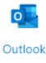
Click on Outlook

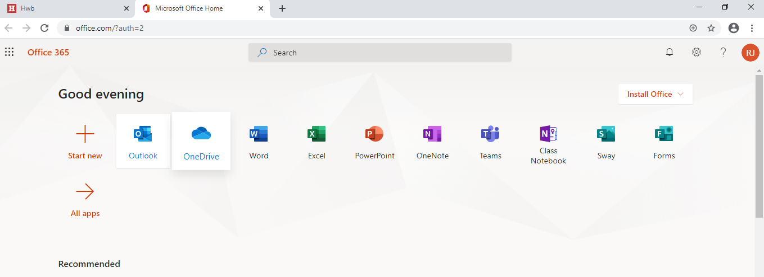

Outlook will open in a new window and now you are ready to read your emails.

Good Luck
Mrs James

