## Communication and Language (CL)

**Personal, Social and Emotional**

I will practice playing in our role-plays with other children, understanding that we play in ways which respect each other, and listen to each other’s ideas.

I will be sharing my home life with my friends during news

I will think about and discuss characters and events in stories, being kind, stealing, etc.

Talk about how we should behave towards family/friends.

I will be talking about how I feel or how characters feel in a book they might be reading, encouraging a wide range of vocabulary e.g., scared, excited, happy, sad etc.

We will discuss caring for minibeasts.

**Literacy**

I will be retelling stories in the correct sequence using and creating story maps.

I will be using my phonic knowledge to read simple regular words.

I will be exploring and experimenting with sounds, words, and text

I will continue to learn phonics.

I will be writing sentences and descriptions.

I will be acting out the roles of different characters.

I will be writing lists, invitations, instructions and letters to characters from the story.

I will think about characters thoughts and using thought bubble and speech bubbles.

## Communication and Language

I will be listening to my friends talk

I will be using talk to organise, sequence and clarify thinking, ideas, feelings and events

I will be learning about a story structure i.e., what happens in the beginning, middle end

I will be talking about what I see, feel, hear and think.

I will be learning new words to ask my friends questions.

I will look at repetitive phrasing in stories.

Spring 1 - Reception

If You Go Down to The Woods Today... 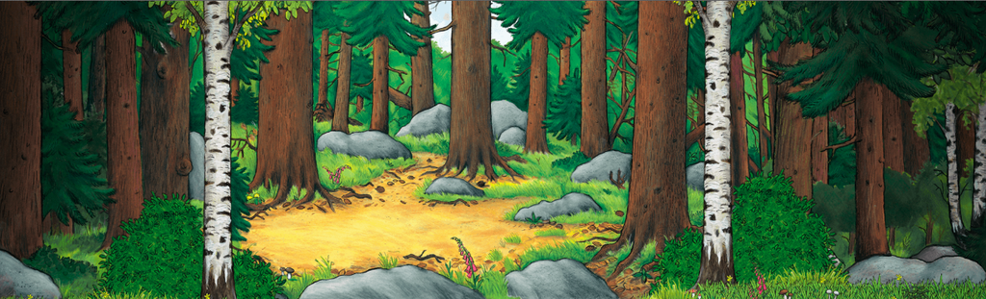

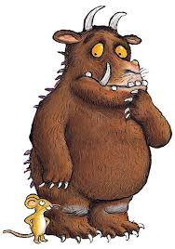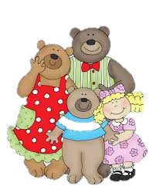

## Knowledge & Understanding of the World

I will be investigating different objects we can find in the woods.

I will look at textures of different materials found outside.

Use cameras to record our adventures in the woods

I will control and direct beebot

I will be learning about plants and growth

I will learn about the life cycle s and mini beasts

I will be using the I pad to research and develop my skills.

I will look at Changes that happen- plants, when things are cooked and through plant investigations.

I will Create maps/follow routes to/from various starting points- through the woods.

## Mathematics

Use everyday language related to time; order and sequence familiar events and measure short periods of time.

I will be learning to count in 1s,2’s10’s and 5’s.

I will be counting to forwards and backwards.

I will order, match and make amounts up to 5, then 10 then further as appropriate.

I will be learning the value of money and using it in my play.

I will be using the language of more, less, addition, double and half.

I will be leaning about 2d and 3d shapes

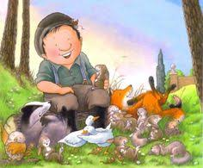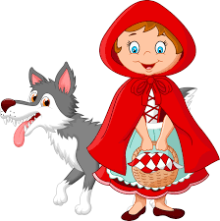

## Physical Development

I will be threading beads to make jewellery

I will be going on a woodland walk and treasure hunt using a range of equipment, travel around, under, over and through balancing and climbing equipment.

I will explore and use equipment to make large- and small-scale constructions- bridges, houses etc.

I will learn and play team games.

Miss Anderson will be joining us for P.E. lessons to help us develop our large and small movements and our skills.

**Additional Challenges**

Can you find out about plants or minibeasts and write facts or draw pictures of them?

Can you go on a minibeasts or plant hunt and draw or take pictures of them?

Can you make a minibeasts model or collage?

## Expressive Arts and Design

I will be studying the work of artists and replicating their work or using their techniques.

I will be painting, drawing through observations.

I will be learning to make different types of costumes using a range of fabrics.

I will be making my own masks/puppets to act out stories.

I will make shelters and minibeasts homes. Using natural materials.

I will be carrying out a range of minibeasts crafts, and weaving activities.

I will be singing simple songs from memory.