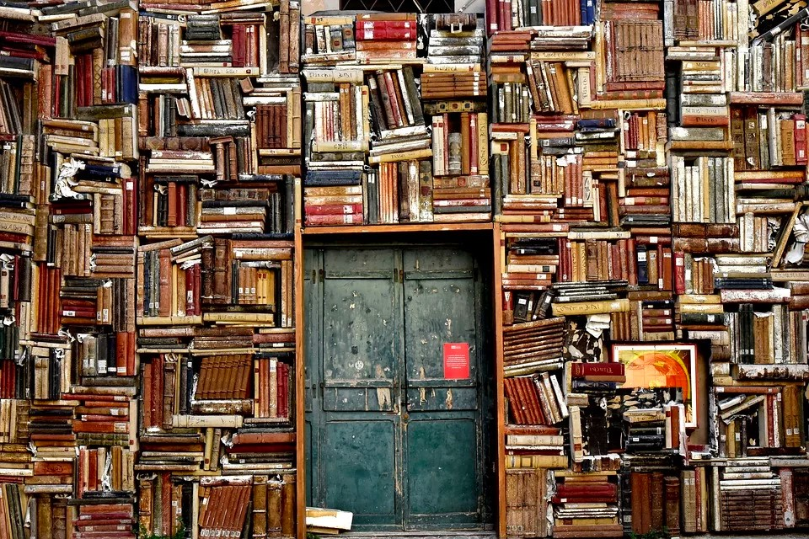
Imagine that you wander through this bookshop door to find another, even stranger shop. This is where the black hat came from. What else is there?
Item (Sketch) | Description of items appearance. | Describe the items magical power.

