Introduction
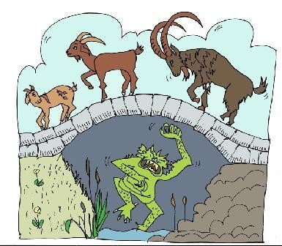
There are many stories that have trolls in them. Trolls, like dragons, giants and unicorns, have been talked and written about for hundreds of years. One very wellknown story, I am sure you will know, is about a very angry troll that tried to stop goats going over a bridge to feed on the rich, green grass.
But is this what all trolls are really like?
The information that follows has been written by Professor Folklore, an expert on Trolls from the University of Myth and Legend.
He provides some basic information on these strange, often misunderstood mythical creatures. You can decide what you think maybe true and what needs more research to establish the truth.
Professor Folklore needs other experts to write more about trolls so that the ‘truth’ can be shared across the world. He wondered whether you could also become an expert on trolls. Can you dream up some of your own interesting and amazing information to set the record straight and not let trolls just be known as nasty, mean creatures?

