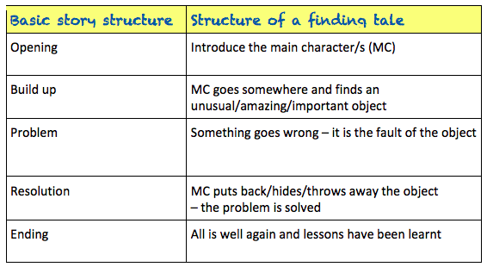

The Game

Danny and Susie were bored. It was wet play again and it felt like they hadn’t seen the playground for weeks. Rivers of greasy rain streaked the classroom windowpanes and pooled to make gigantic puddles in the centre of the netball court. Another lunchtime inside was clearly stressing Mrs Allbright, as she seemed to be tense and a bit more snappy than usual. She sat at her desk with a steaming cup of tea and marked books with the ferocity of a wild beast. To top it all, every good game was being used and only the tub of dominoes was left. Everyone knew that half of them were missing and the other half had been chewed by the school ‘Reading Dog’. Danny and Susie searched the classroom for something to do.

To their dismay, the comic box was empty, the iPads had been snapped up by Freya and her gang and Billy seemed to have started a resurgence of the game Slap, which didn't look like fun at all. As the two friends squeezed past the art table to get to the wet-play books, a tatty, cardboard box fell from the top shelf of the bookcase. Susie picked it up.

“I’ve never seen this game before,” she said, wiping the dust from the unusual lid. It was embossed with intricate patterns and around the edges were pictures of animals, insects and other strange creatures.

“An animal game? Boring!” said Danny, already losing interest.

“Oh come on, let’s play. There’s nothing else to do,” suggested Susie, smiling widely and shaking the box.

They sat down in a quiet corner, lifted the lid and took out the board.

“Looks simple enough,” said Danny, ever impatient, as he set the counters onto the start line. They were jungle animals: a rhino and a jaguar. He also shuffled the game cards and laid them in a neat pile. “Let’s just start and learn as we go.”

Susie went first. She grasped the dice and threw them down onto the centre of the board. An eight! She moved her rhino eight paces, to land on an orange-coloured square. It showed a picture of a giant Tarantula. She lifted a game card and read it out. “If you do not catch this beast, then you’re on the menu for its next feast.” She stared at Danny and shrugged. “I don't get it!” she said.

At that moment, the table began to shake, the windows rattled and the floor vibrated. Everyone stopped what they were doing and the room fell silent.

“EARTHQUAKE!” shouted Billy, bursting into laughter. He soon stopped, as in a blink of an eye, an enormous spider, bigger than a horse, shot out of the game and landed in the centre of the crowded classroom. Everyone froze. Its enormous, hairy legs were tensed, ready to pounce and its whole body seemed to pulse. Eight, bulging eyes scanned the room and then …

It sprung into action. It crushed the tables, smashed the windows and flung children all around the classroom with a flick of its legs. It powered towards Mrs Allbright as she stood rooted to the floor in terror. The room was filled with shrieks of panic and despair.

“What shall we do?” shouted Danny desperately, pressing himself tightly against the wall.

“Read the instructions,” ordered Susie. “We have to stop it!”

Quickly, they scrabbled around to find the box underneath all the mess. They rescued it from under a pile of maths books and scanned the upturned lid to read the instructions. All the while, the spider got closer and closer to their teacher. It stretched out its forelegs, ready to grab her. Her eyes widened in horror as she realised what was coming next.

“It says we’ve got to throw two sixes to end the game,” screeched Danny, looking pale. Susie grasped the dice again. She threw and she threw and she threw. No luck. She glanced up and saw the spider had her teacher in its grasp. Its striped legs were holding her in a vice-like grip. She threw again and then again, faster and faster each time and then, just as she was losing all hope, TWO SIXES!

Suddenly, out of nowhere, there was a loud hissing sound. It pierced the air and everyone covered their ears. A flash of light streaked through the classroom and the game rattled into life. It started to suck everything into a vortex in the centre of the room: the mess, the children, the spider, Mrs Allbright. There was an almighty boom and then … nothing.

Danny and Susie opened their eyes. Everything was back to normal; even Mrs Allbright was back in her chair, marking with the ferocity of a wild beast. Then the bell went.

“Pack up, Class 5!” ordered Mrs Allbright. “Science starts in two minutes and we’re looking at animals in their habitats.” Susie looked at Danny and raised her eyebrows. They carefully packed the contents of the game back into the box. Everything went in except the dice and the animal counters, which Susie wrapped in a paper towel and placed into the bin instead. They put the lid on the box and lifted it high up onto the bookshelf. They never wanted anyone to play that game, ever again!

Everyone settled down to afternoon lessons. Everyone, that was, except Billy. He had spotted something on top of the bookshelf that he’d never noticed before and he intended to investigate it, the very next time they were in for wet play …

