Can I cut out and stick pictures of jungle animals inside the letter sound j? Can I name and count them then record how many I used?

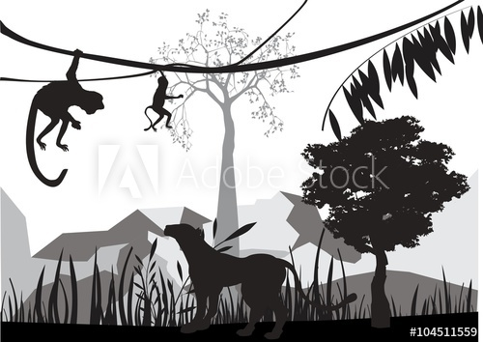j is for jungle animals.

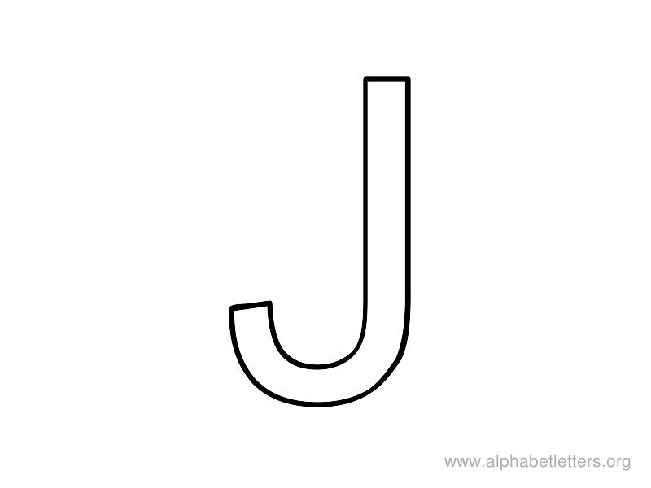

My words beginning with j :-

I counted jungle animals.