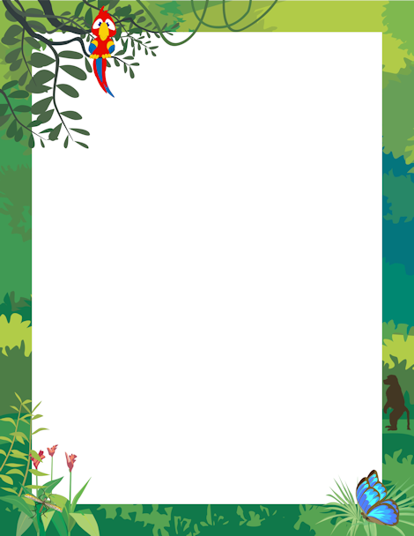

There’s a rumble in the jungle,

There’s a whisper in the trees

The animals are waking up

And rustling the leaves

The hippo’s at the waterhole,

The leopards in his lair,

The chimpanzees are cheering,

And swinging everywhere!

Some animals are frightening,

And some are sweet and kind,

So let’s go to the jungle now

And see who we can find ...