*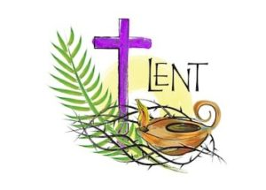An acrostic poem by* __________________________