W/C 18-1-21
WALT: Can I say and write the letter sound ‘n’-firstly
using my finger, then using 5 different coloured
pens?
Can I say words beginning with the letter sound ‘n’?

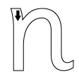
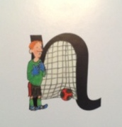
Say “Down Nobby and over his net”

My words which begin with our letter sound ‘n’: -

