**Physical**

**This week our letter sound is ‘j’.**

**Imagination game -** **Let’s pretend to Move like different jungle animals. What parts of my body do I need to use for each one? Can I jump like a kangaroo?**

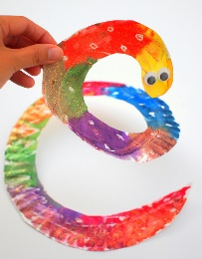**Creative**

**Jungle snake hanging mobiles. Follow this link to see how to make your very own Paper plate jungle snake.**

<https://www.mybaba.com/paper-plate-snakes/>

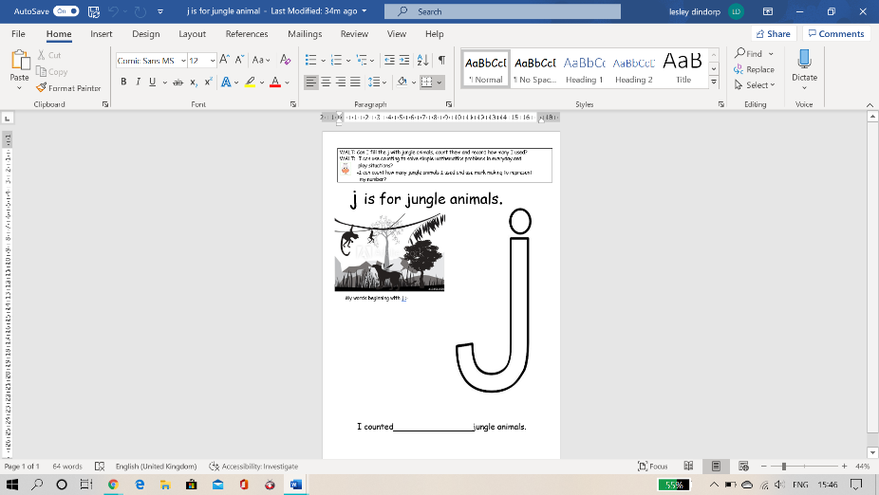**Maths**

**Counting jungle animals. Can you find pictures of jungle animals,**

**cut them out and stick them into the letter sound ‘j on the**

**worksheet sheet?**

**(See attached file names Jungle animals work sheet)**

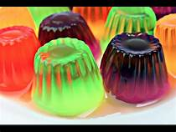**KUW – Making jelly.**

**Learning about how some foods can change shape. Think about the food jelly. It can be melted and cooled to change its form/shape. With an adult’s help follow the instructions to make jelly. Can you remember how you made it? See if you can explain what you did to someone special.**

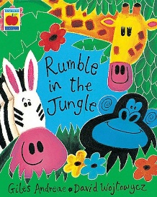

**Language, Literacy and Communication**

**Learning about jungle animals -Read the story Rumble in the Jungle.**

[**https://youtu.be/jBi2tsD2iUQ**](https://youtu.be/jBi2tsD2iUQ)

**Personal, Emotional and Social Development**

**Invite the children to discuss whether animals are happier in the jungle or in the zoo?**

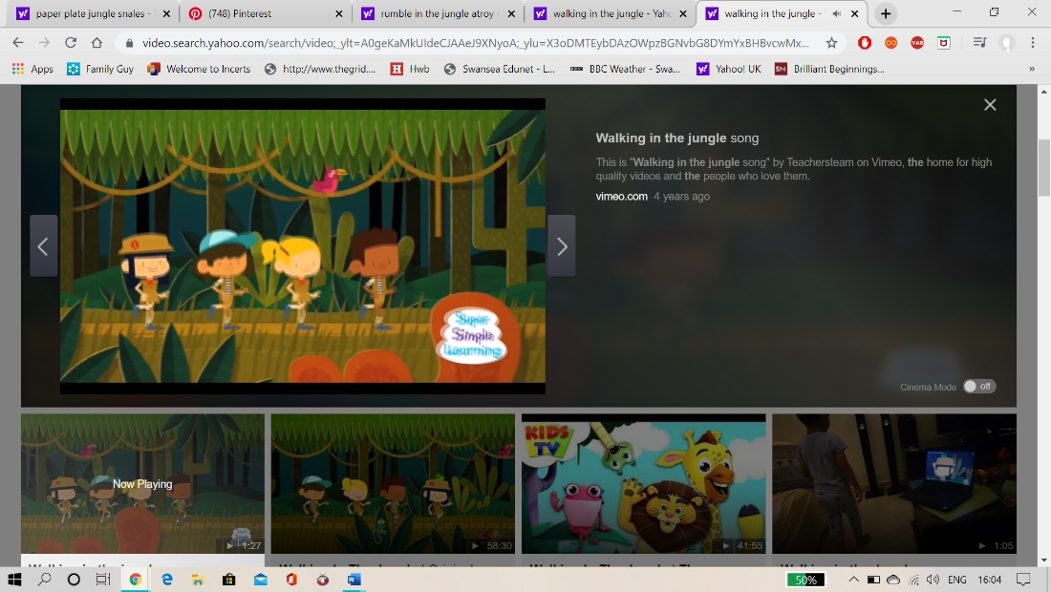

**Stories and Rhymes**

**Can you remember one of our favourite songs from nursery? Walking in the jungle?** [**https://www.youtube.com/watch?v=GoSq-yZcJ-4**](https://www.youtube.com/watch?v=GoSq-yZcJ-4)

Don’t forget if you want to post any of your beautiful work on our @Penyrheol2 twitter account please do so – Mrs Dindorp



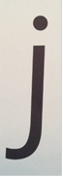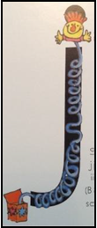

down his body, curl and dot

down his body, curl and dot

