Lifecycles

**Use the cards to show the lifecycles of a flowering plant and different animals. Order the cards to show the full lifecycle.**

**Can you write a description of one of the lifecycles?**

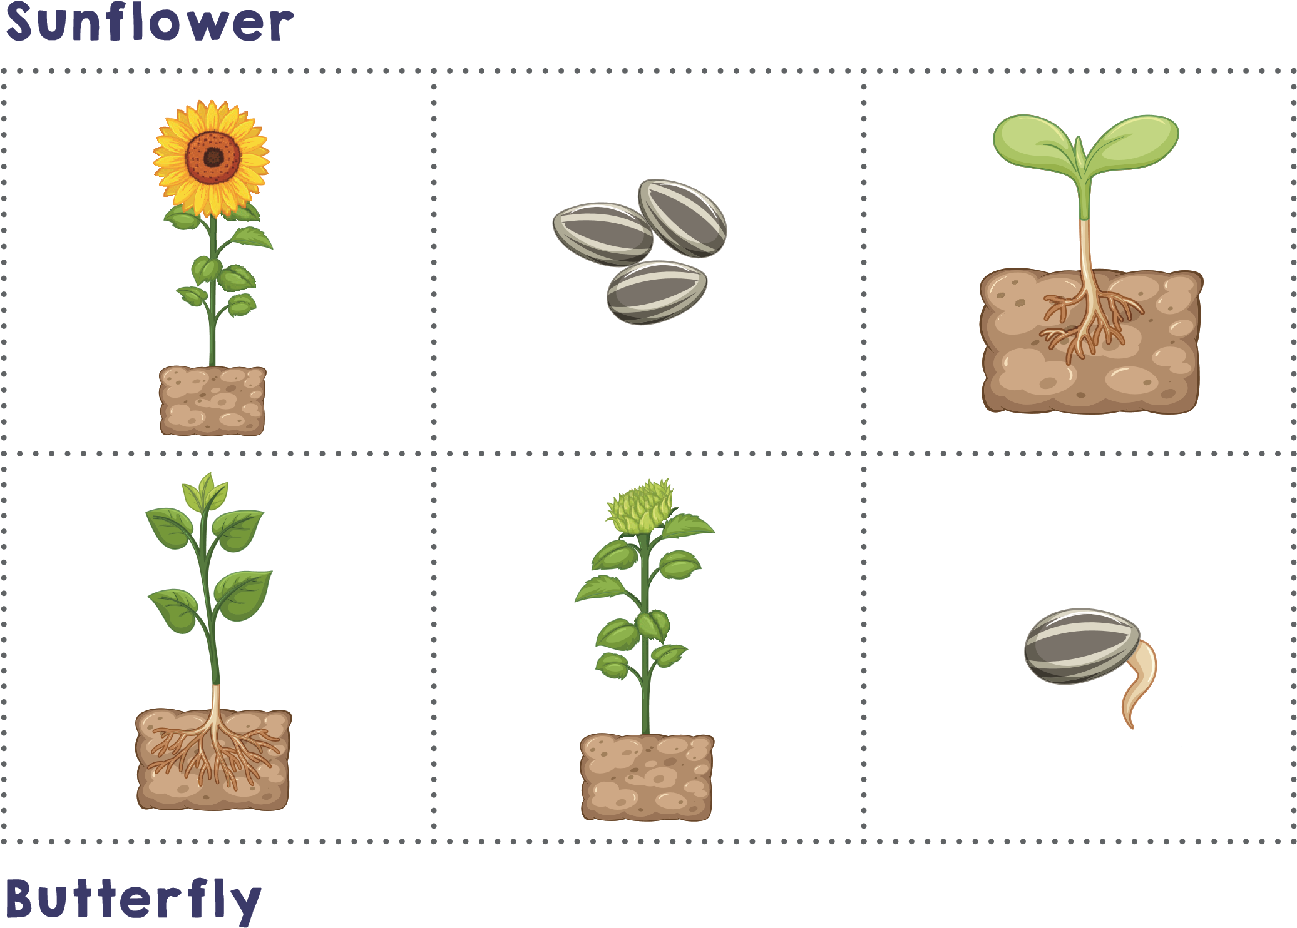

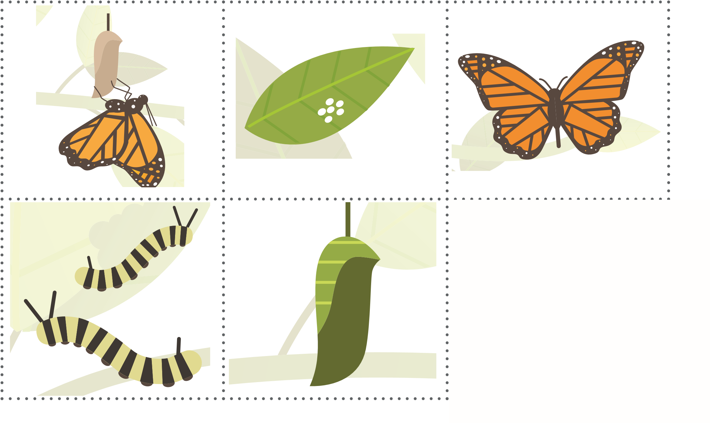

Frog

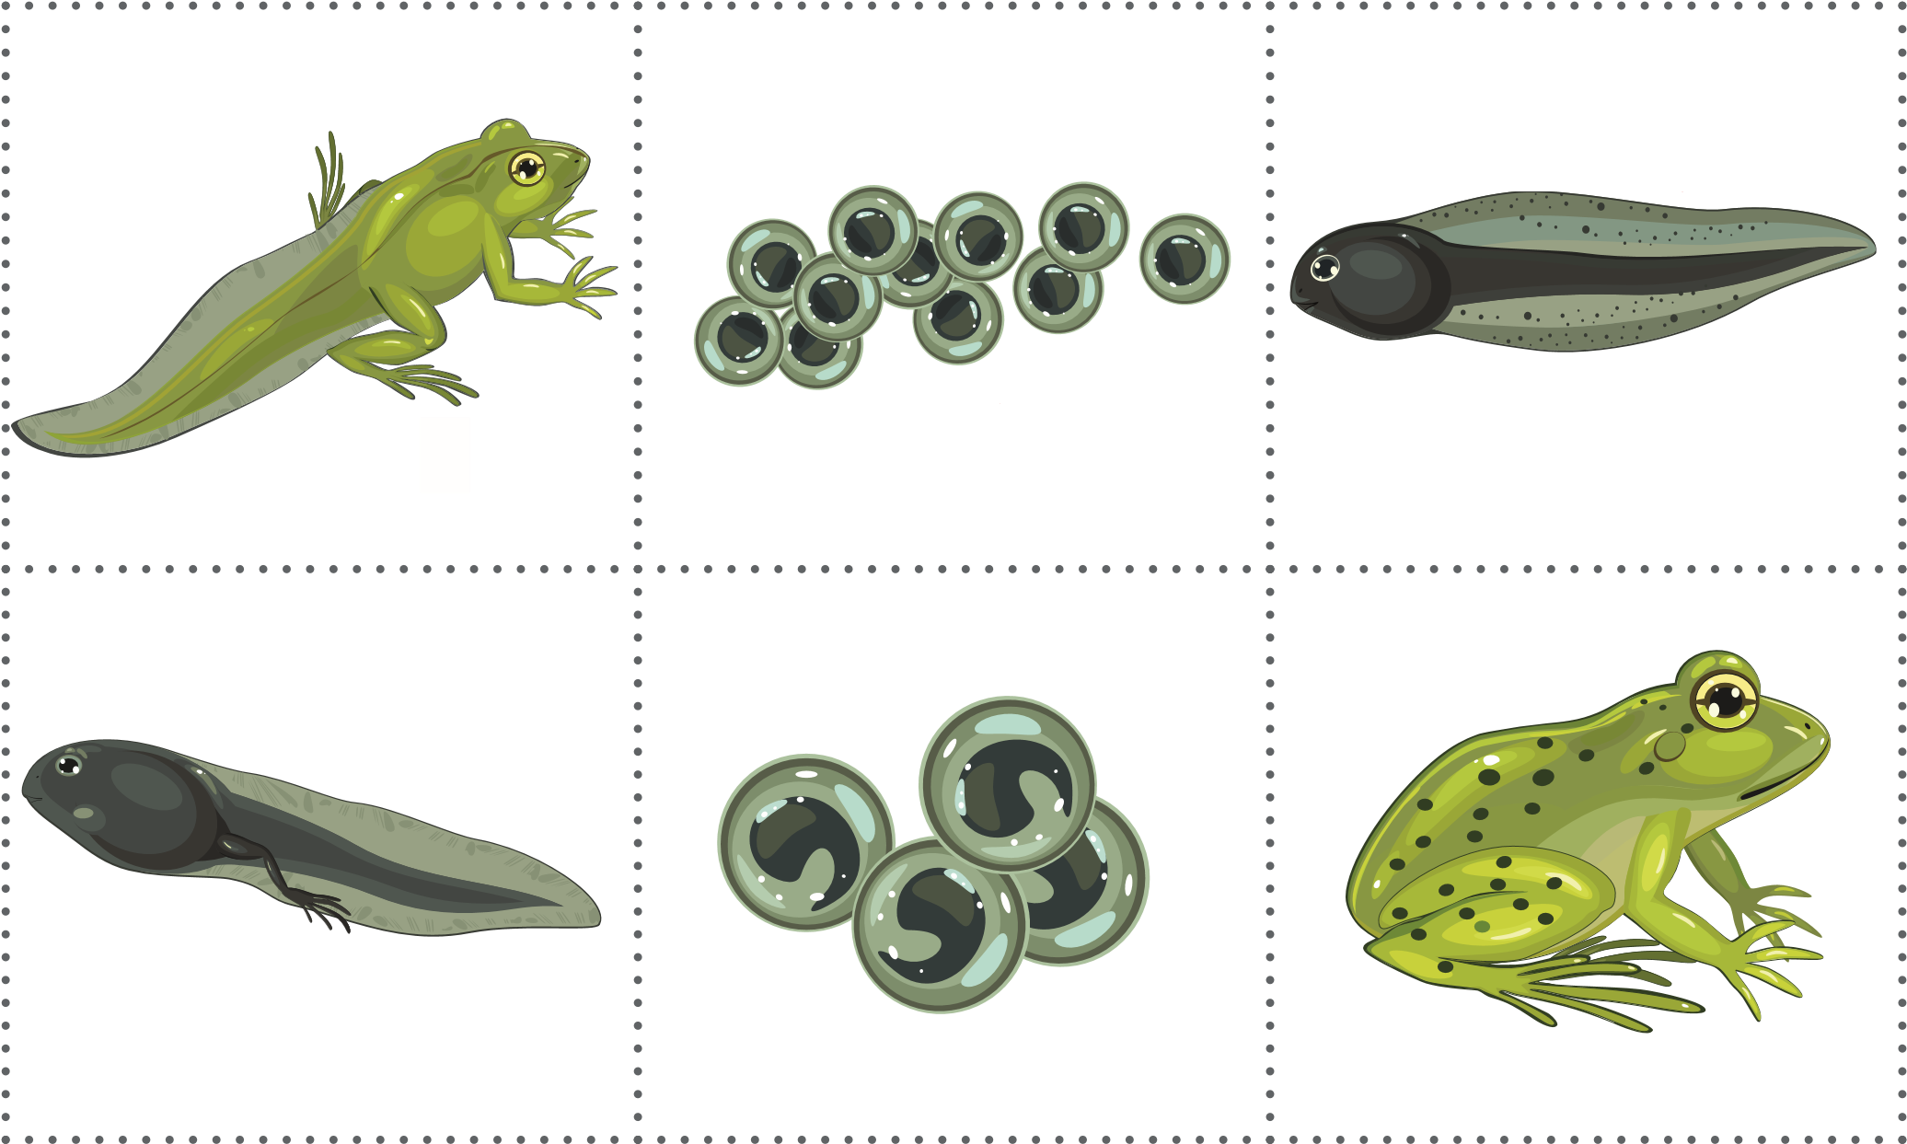

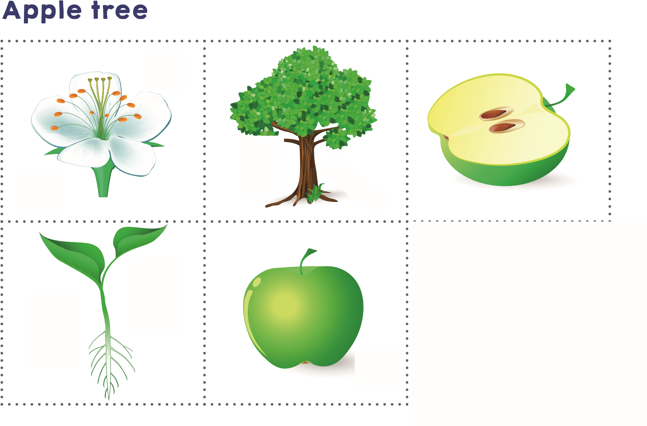

Ladybird

