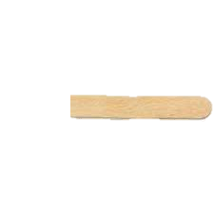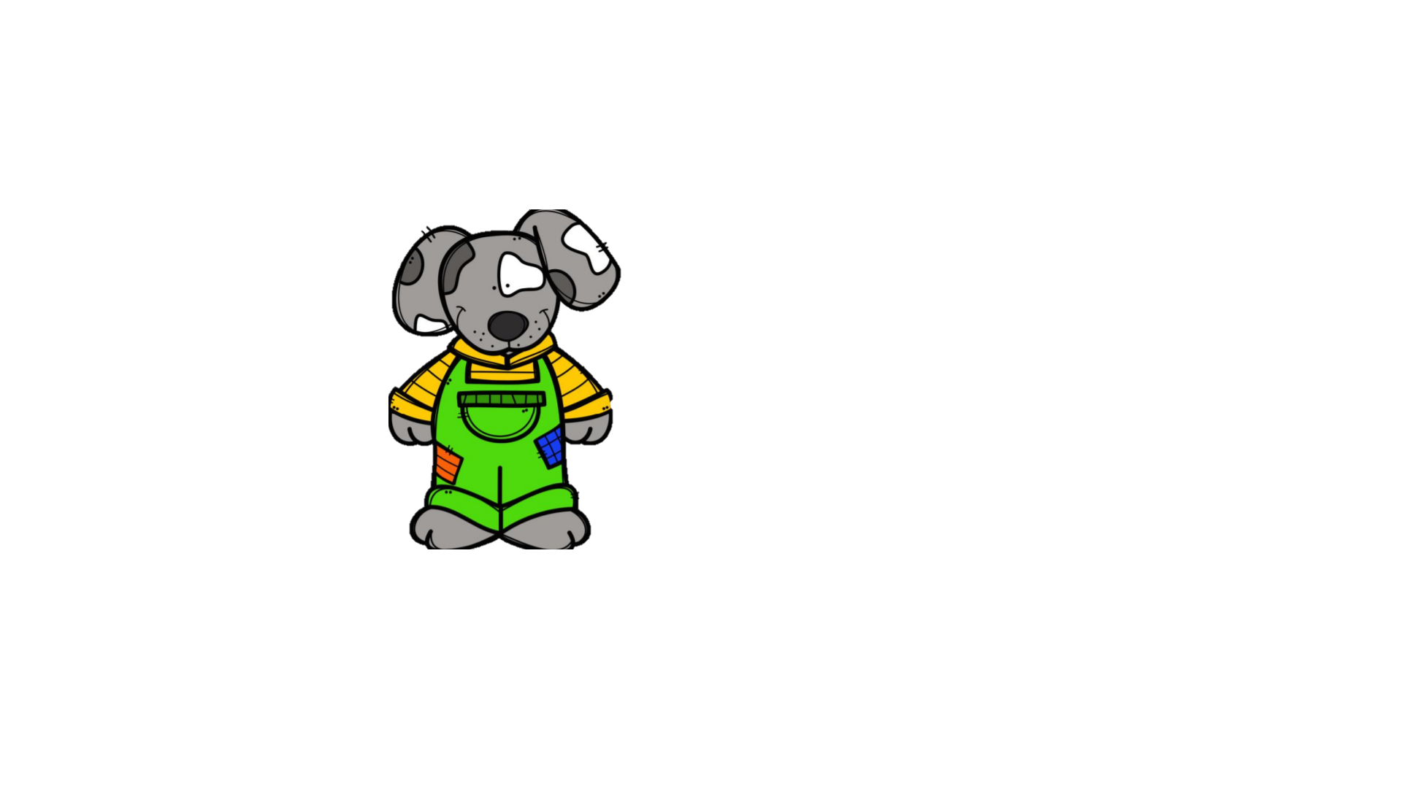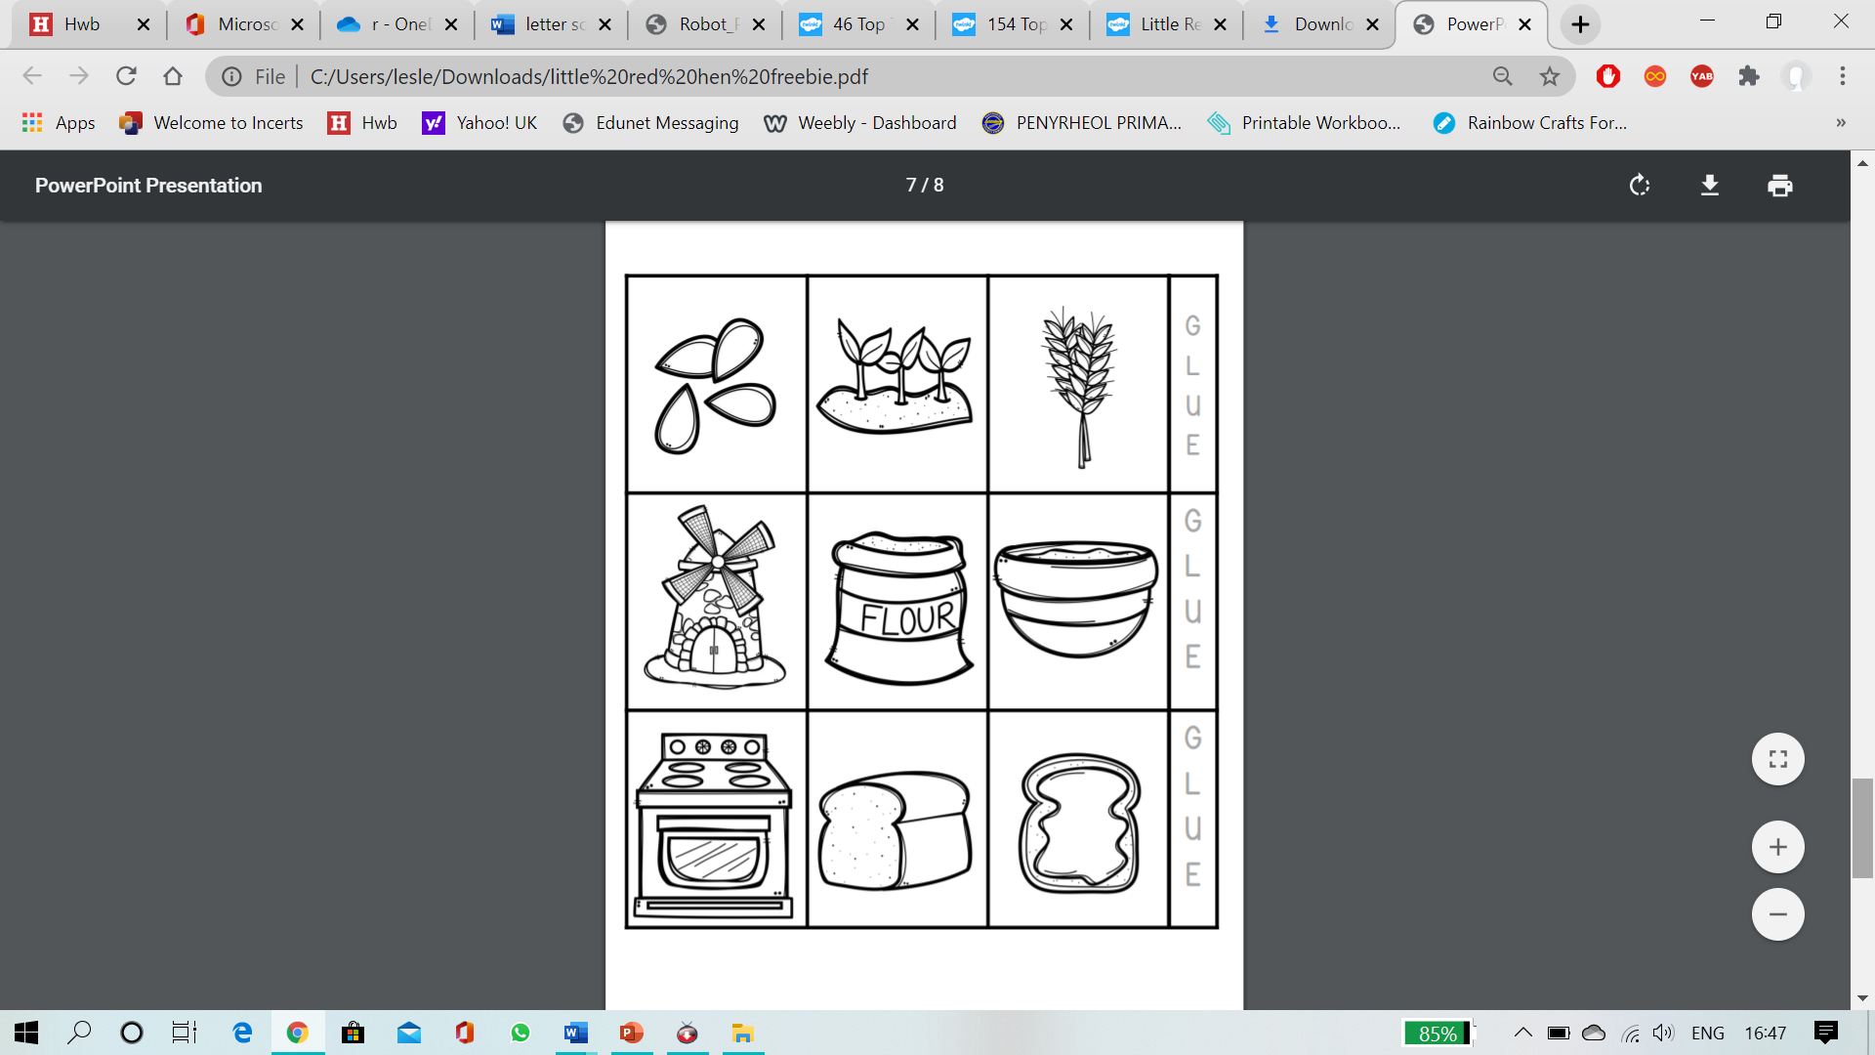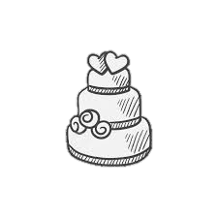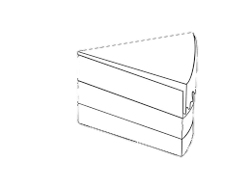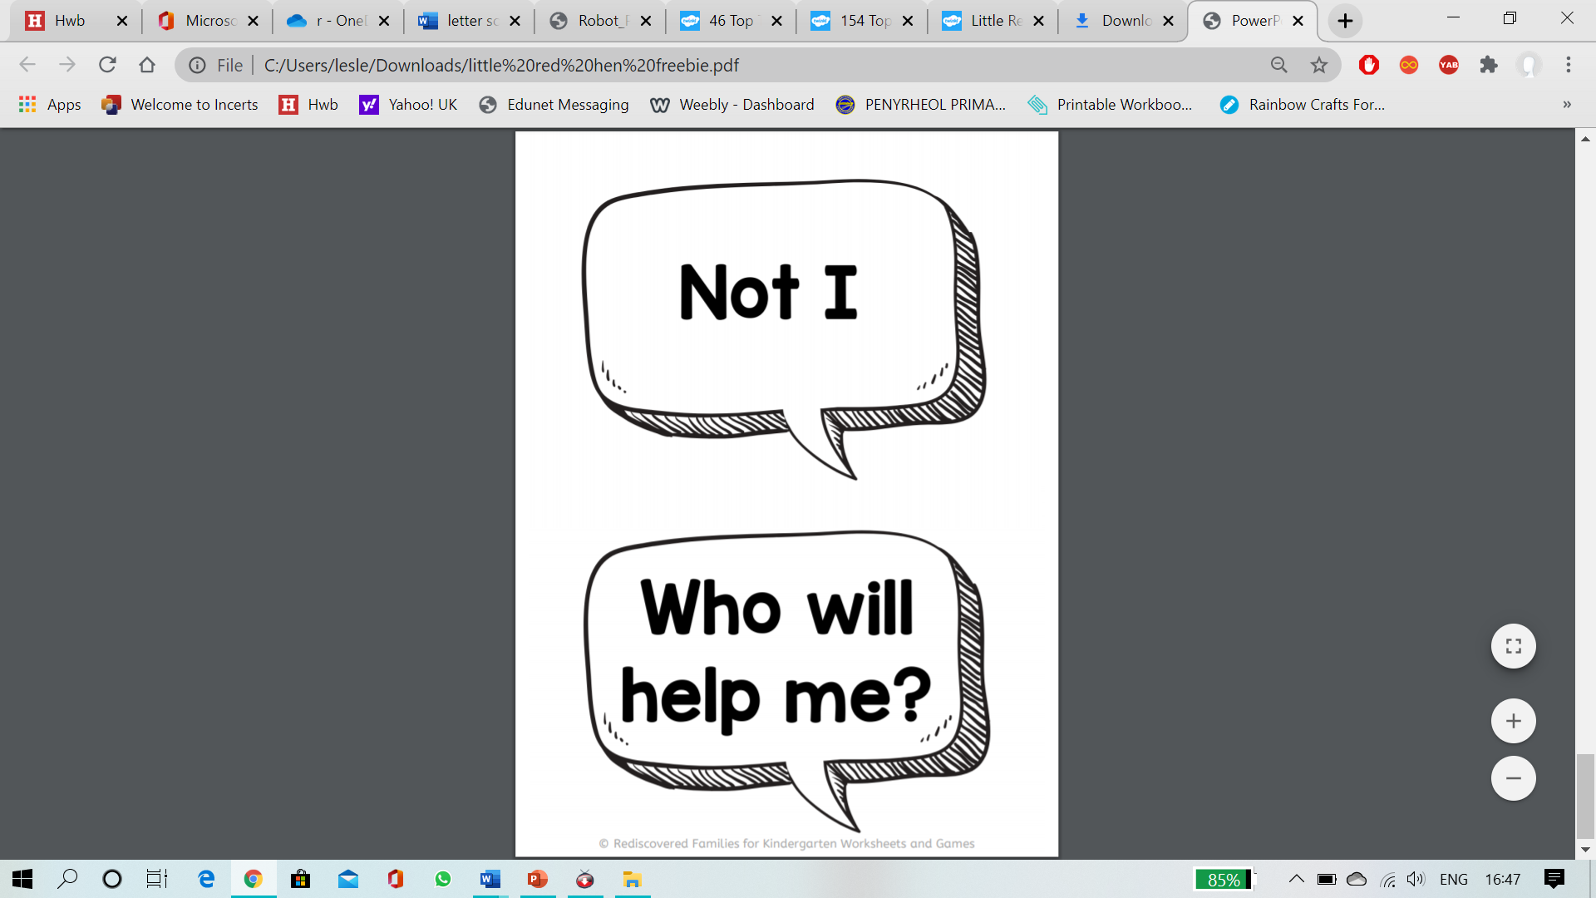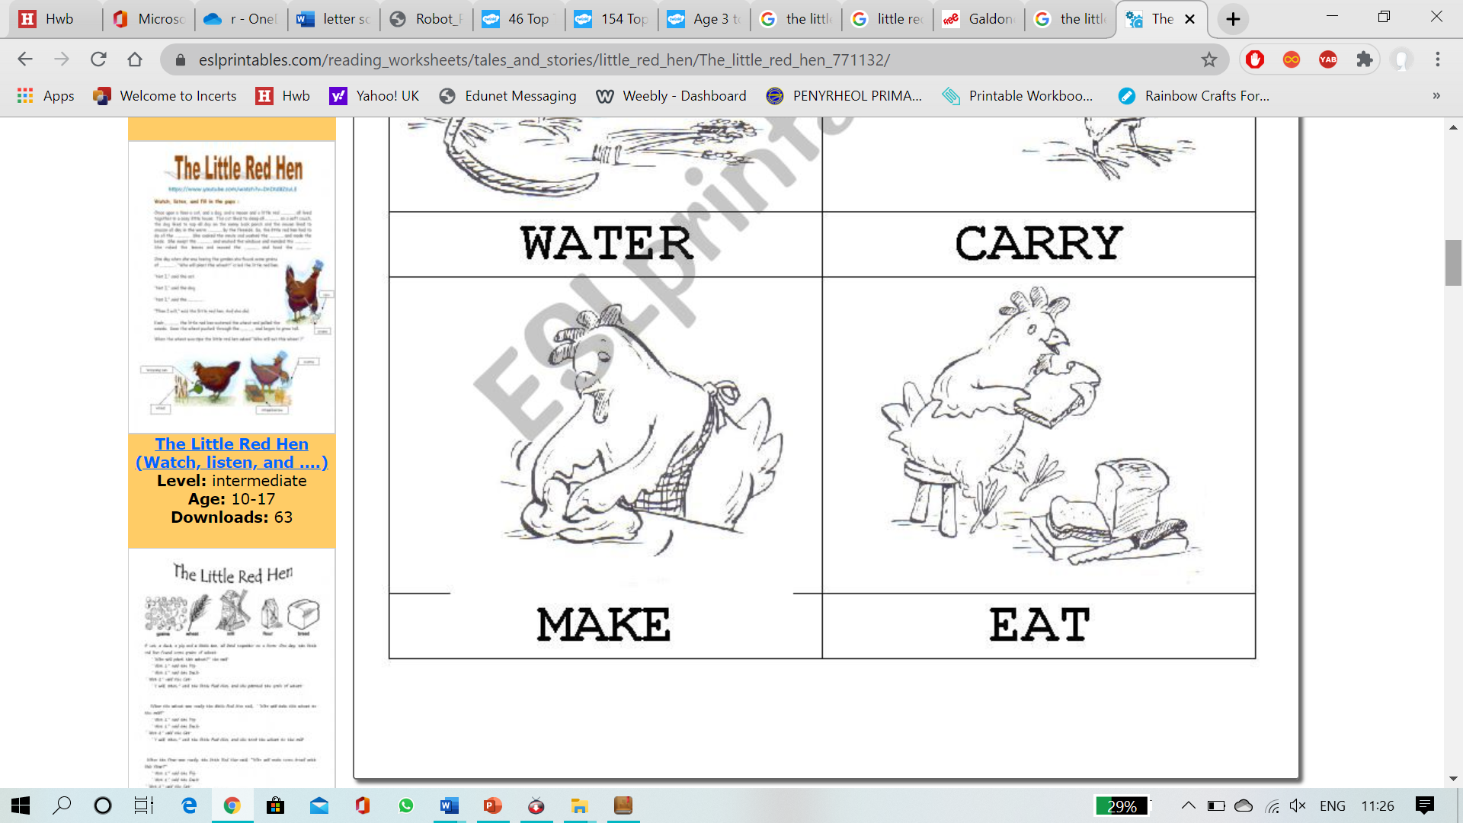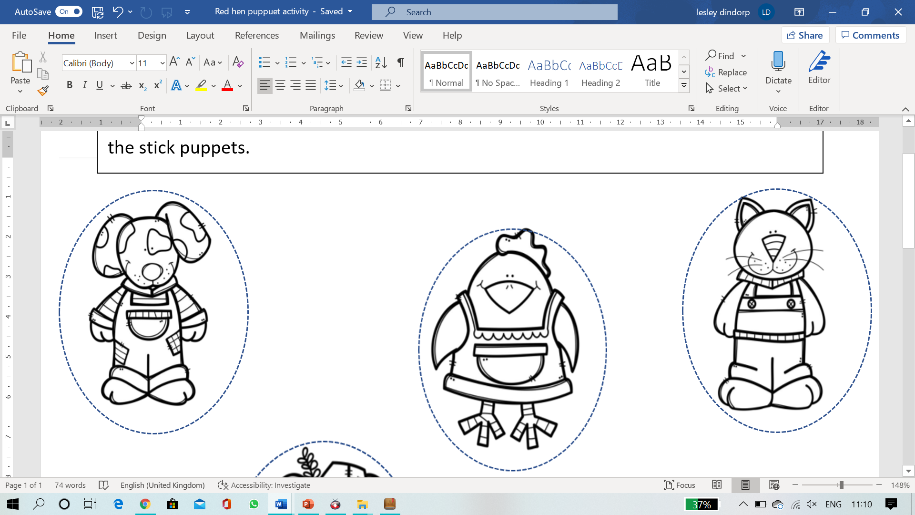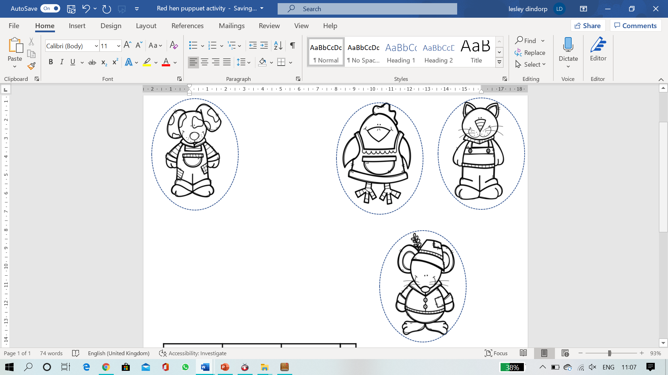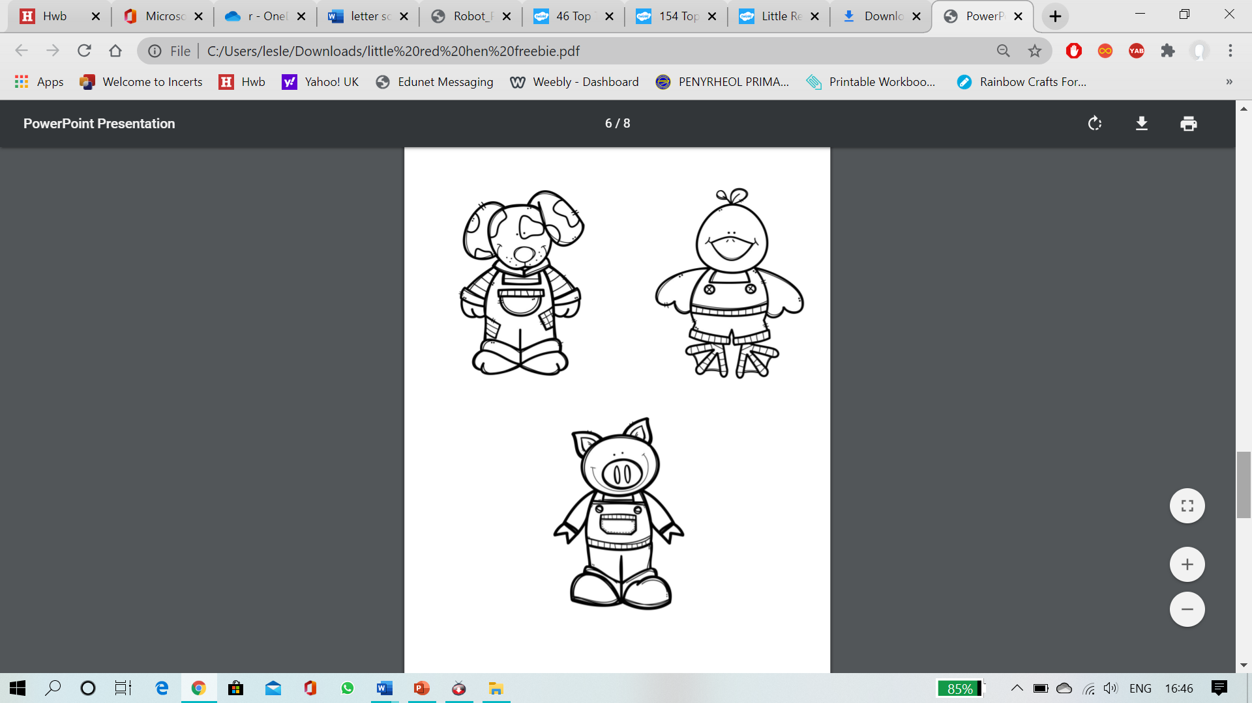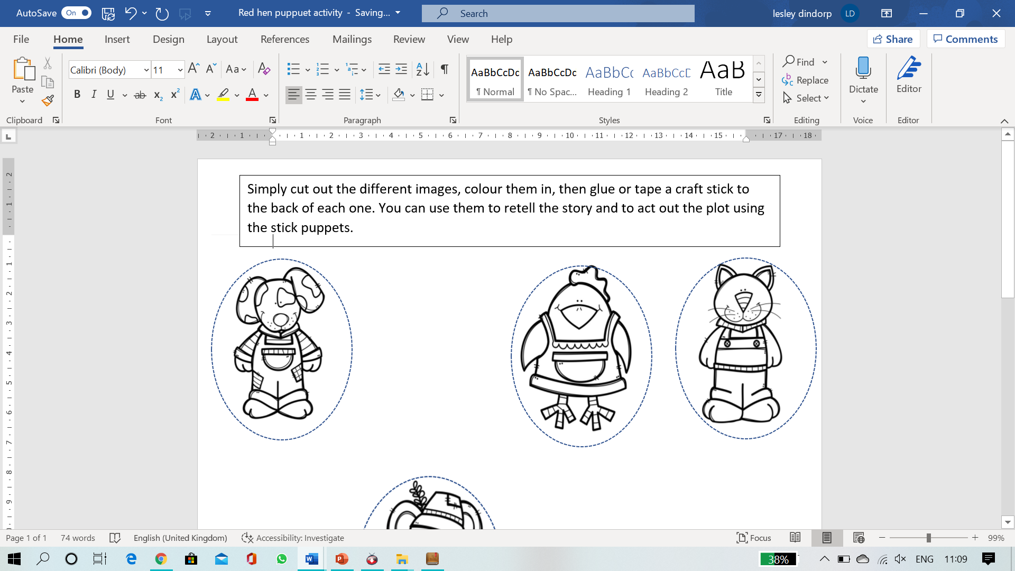V

Use these images to help you remember the story.

Cut out the different images and speech bubbles, colour them in, then glue or tape a craft stick to the back of each one. You can use them to retell the story and to act out the plot using the stick puppets. (You can see the dog below is an example of how they could look.)

Who will take the flour to the bakers?

To the bakers

Who ate the cake?

Who will eat the cake?

Who will cook the cake?

Who will make the cake?

Who will take it to the mill?

Who will cut the wheat? this wheat?

Who will plant this wheat?

Hen found some wheat.