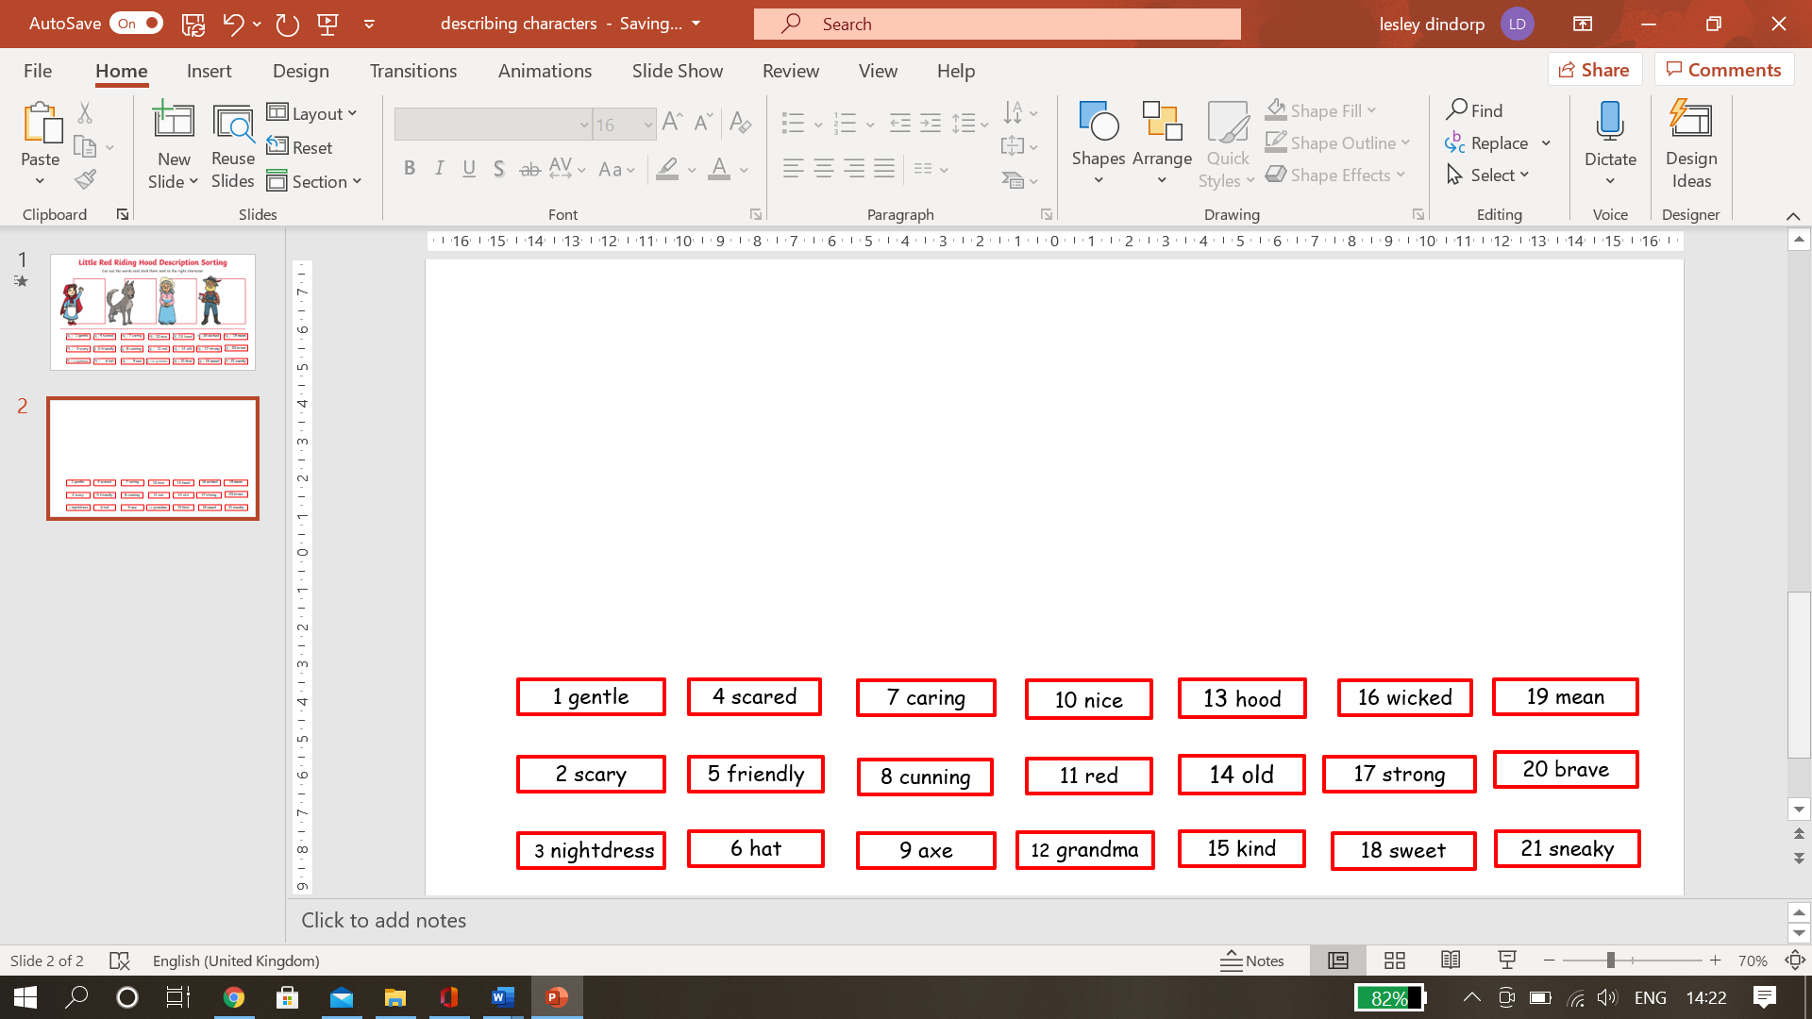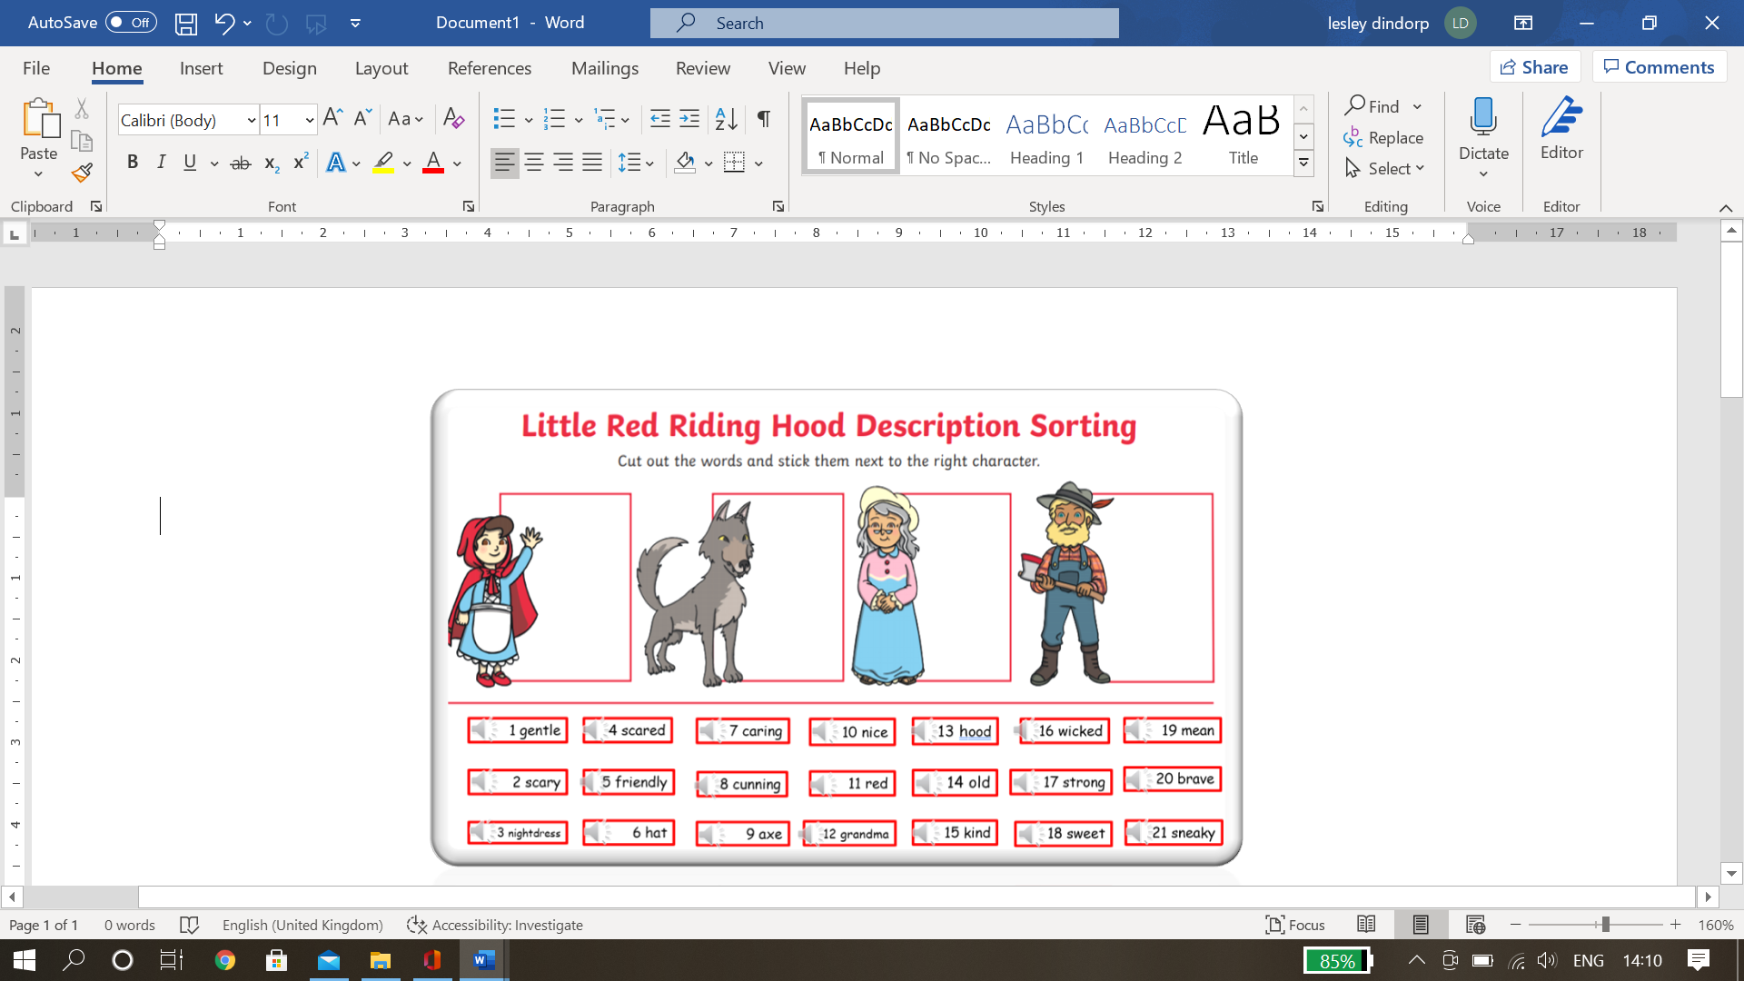

Can you ask an adult to help you read the words below? If you prefer a challenge you can open the power point link on the class webpage and click on the sound icon to hear the words. Cut out the words and stick them next to the correct characters.