[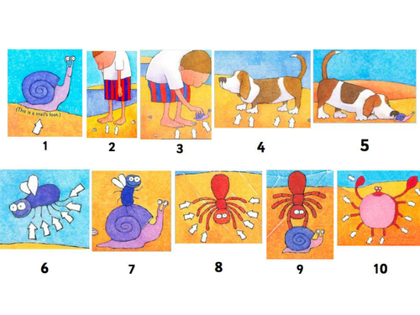](https://www.google.co.uk/url?sa=i&rct=j&q=&esrc=s&source=images&cd=&cad=rja&uact=8&ved=0ahUKEwjfo7zjhsTNAhXEAcAKHfKFBzQQjRwIBw&url=https://www.tes.com/teaching-resource/one-is-a-snail-ten-is-a-crab-eyfs-reception-addition-recording-maths-problems-counting-to-20-11238968&bvm=bv.125596728,d.ZGg&psig=AFQjCNEz1UFY5Yzo3-K6ajnaCYtwnQwX7Q&ust=1466974160752471)

How many ways can you make **30** legs?

Use the characters in the story