Making your Flip-grid

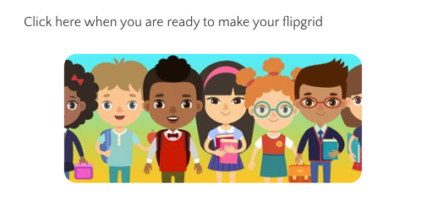
Step 1 – click on the link on the classpage

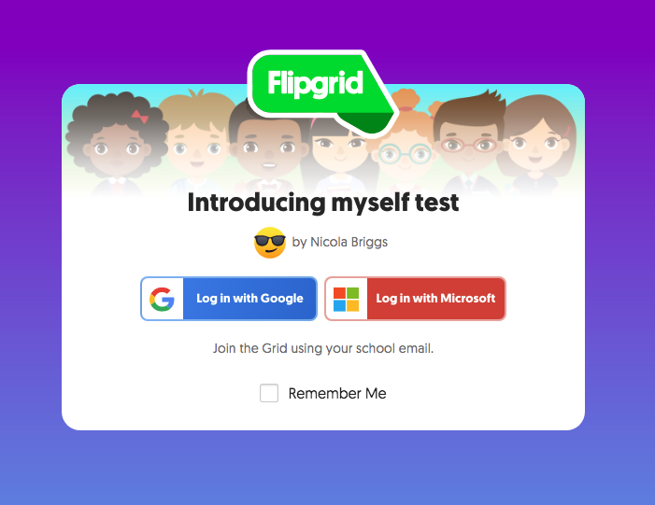
Step 2 – Log in with Microsoft using your HWB username and password

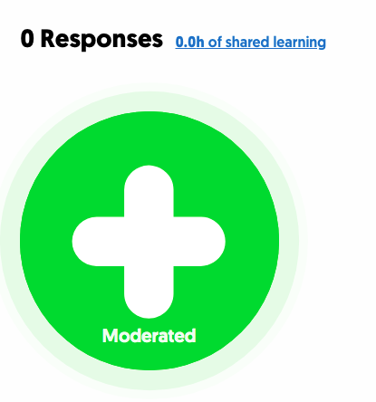
Step 3 – Create your video

