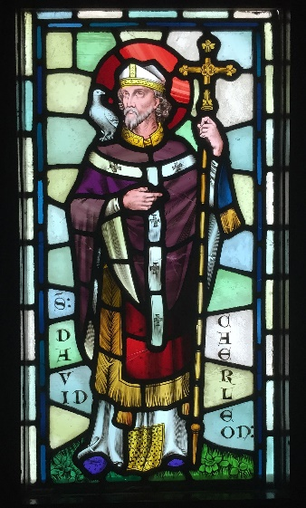

Mat Geiriau Dewi Sant

Dewi Sant – St David Beibl - Bible Peulin - Paulinus

Eglws – church Cennin pedr - daffodil Wales - Cymru

ddraig - dragon Sant - Saint Baner – Flag

mynachdy - monk llysiau – vegetables bara – bread

gweddïo – pray Eglwys Gadeiriol – cathedral