Travelling to School
We took a survey of a class to find out how they travel to school. The results are below in a frequency table.
Task 1: Complete the frequency table.
How do you travel to school?
 | Tally |  | Number
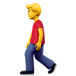
Walk
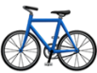
Cycle
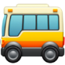
Bus
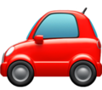
Car
Other
 |  | TOTAL

Task 2: Display the information in a bar chart.

