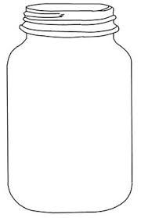

Something I enjoyed …..

Something I learned …..

Someone I helped …..

Something I made …..

My favourite moment …

My best memories

Memory Jar



5 things I have learned about myself…..

What are you looking forward to in the next months ……

Something I found difficult / least favourite part…..

Memory Jar

My best memories