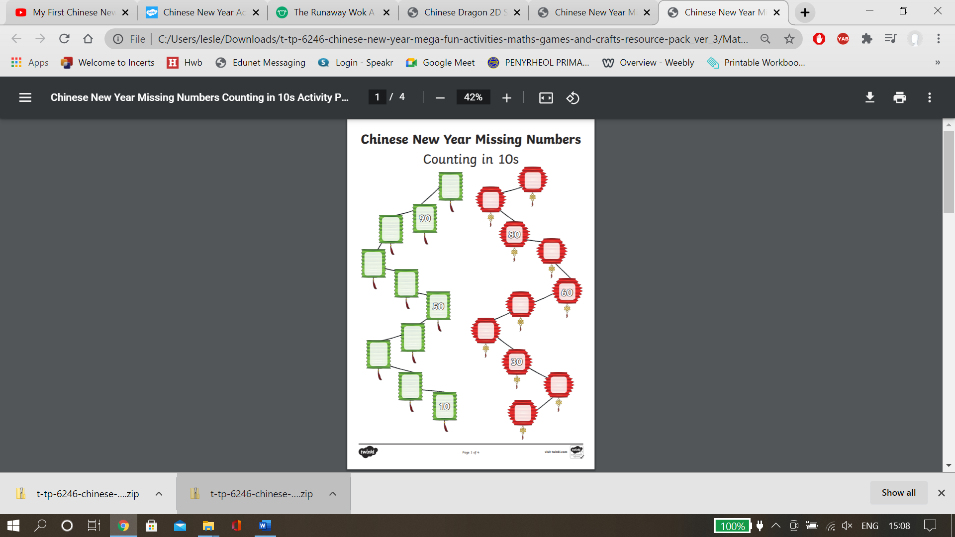

1

5

9

4

1

7

10

Counting backwards in 1s