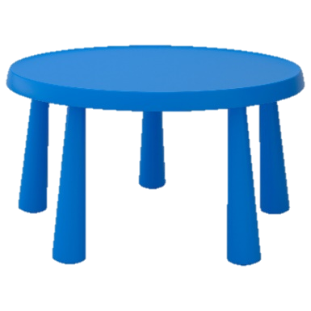
Bore da Mr. Urdd - Good morning Mr. Urdd.
- Can you point to the Mr. Urdd on the table?
- Can you point to the Mr. Urdd next to the table?
Bore da!
- Can you point to the Mr. Urdd under the table?
- Can you point to the Mr. Urdd behind the table?
- Can you point to the Mr. Urdd in a box?
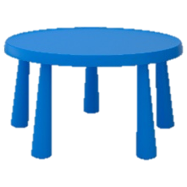
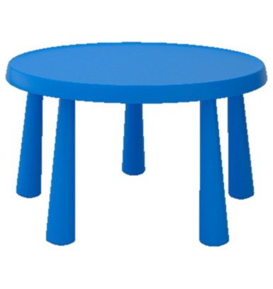
- Can you point to the Mr. Urdd between the table and the box?

