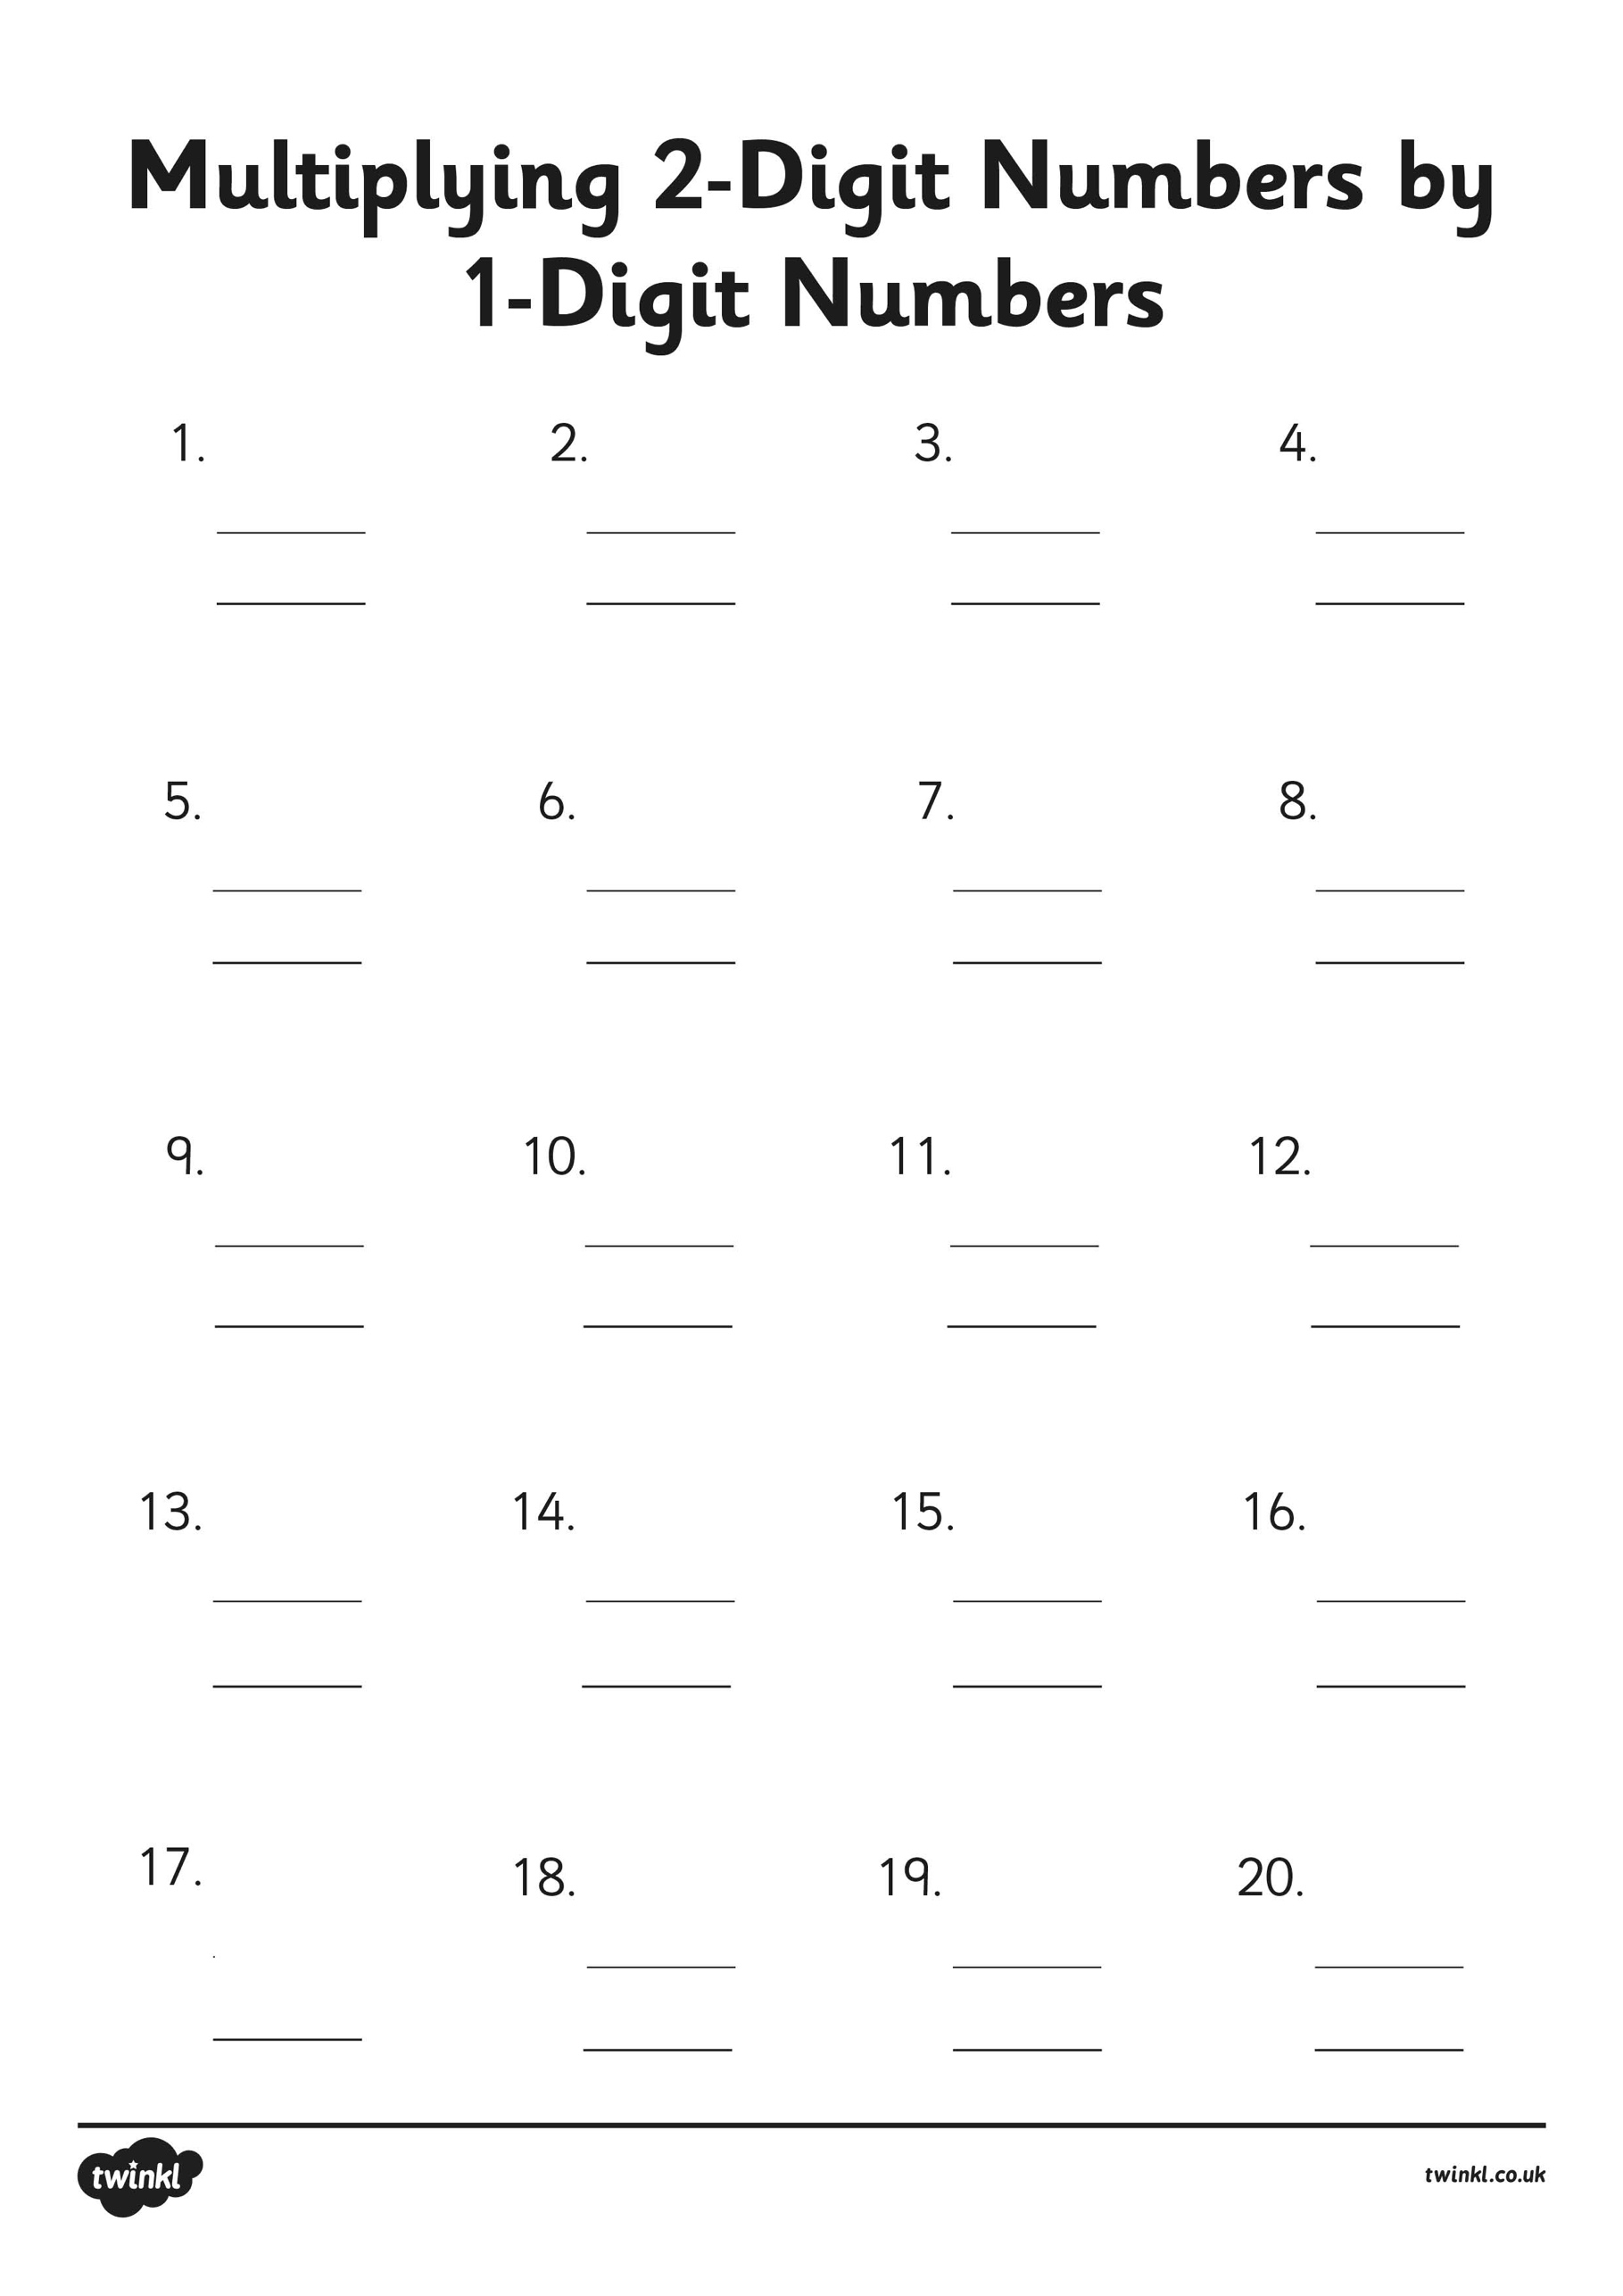

________

78

x 7

68

x 6

75

x 3

85

x 4

82

x 4

87

x 8

94

x 8

53

x 8

66

x 4

62

x 3

32

x 7

44

x 7

12

x 5

48

x 2

41

x 9

31

x 7

18

x 5

26

x 3

22

x 5

24

x 4