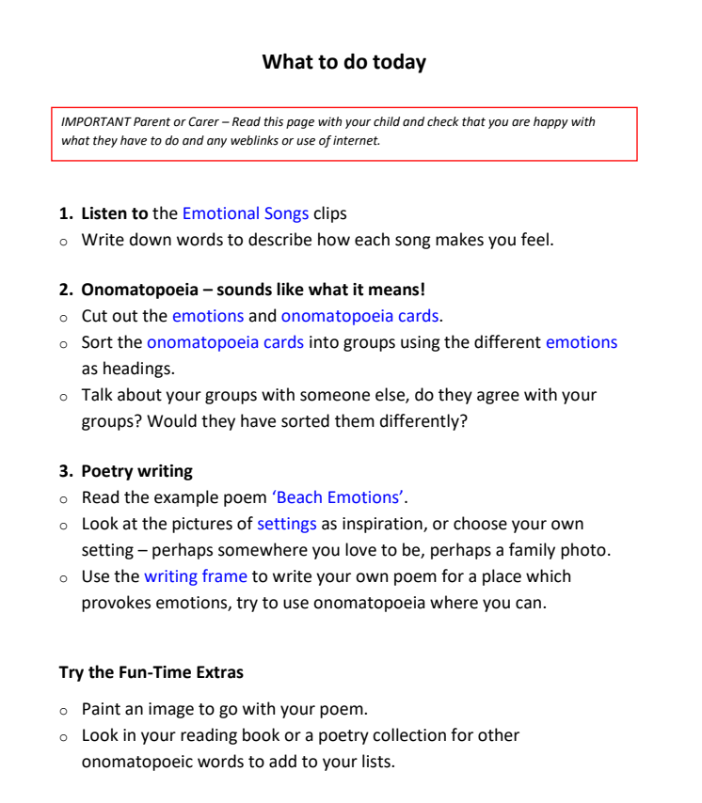

- Albatross by Fleetwood Ma (calm) - https://www.youtube.com/watch?v=QooCN5JbOkU

- Happy by Pharrell Williams (Happy)- https://www.youtube.com/watch?v=y6Sxv-sUYtM

- Hallelujah by Leonard Cohen (sad) - https://www.youtube.com/watch?v=ttEMYvpoR-k

- Someone you loved by Lewis Capadli (sad) - https://www.youtube.com/watch?v=bCuhuePlP8o

- Ride of the Valkyries by Wagner (anger) - https://www.youtube.com/watch?v=V92OBNsQgxU

