An Amazing Fact a Day
Negative Numbers and Temperature

Amazing Fact
The highest temperature ever recorded at the South Pole is -12.3ºC, making it one of the coldest places on Earth.

Challenge
Complete the activities using negative numbers in a temperature context.

- Put these temperatures in order, the coldest first. a. 2˚C, -8˚C, -1˚C, -6˚C, -4˚C

b. 6˚C, 10˚C, -15˚C, -11˚C, 14˚C

c. 16˚C, 18˚C, -23˚C, -25˚C, -13˚C, 12˚C, 20˚C

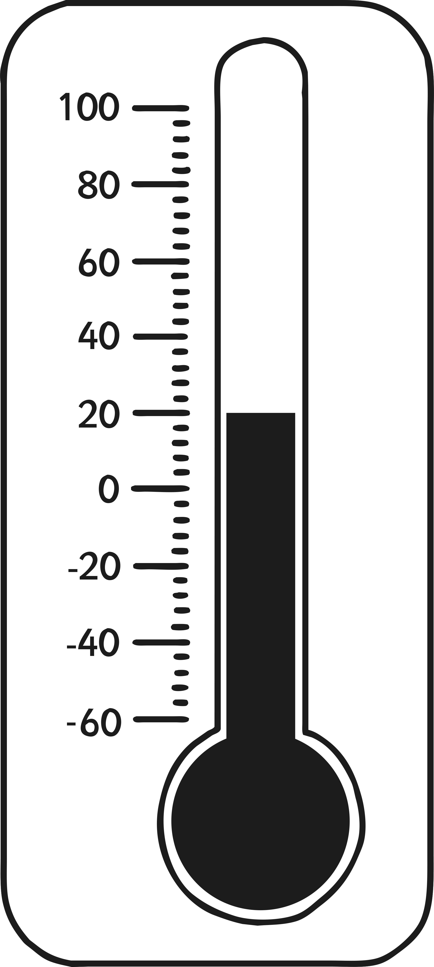
- Which of these temperatures is lowest?

  - -4˚C or -2˚C

  - -8˚C or 8˚C

c. -16˚C or -17˚C

d. -5˚C or -6˚C

An Amazing Fact a Day Negative Numbers and Temperature
- Answer the questions below:

  - The temperature rises by 15 degrees from -4˚C. What is the new temperature?

  - The temperature falls from 11˚C to -2˚C. How many degrees does the temperature fall?

  - The temperature is 6˚C. It falls by 8 degrees. What is the temperature now?

  - The temperature is -3˚C. How much must it rise to reach 5˚C?

  - What is the difference in temperature between -4˚C and 14˚C?

  - The temperature was -5˚C. It falls by 6 degrees. What is the temperature now?

  - The temperature is -11˚C. It rises by 2 degrees. What is the temperature now?

  - The temperature is -20˚C. How much must it rise to reach -5˚C?

You could also try to find out:
- which places, if any, are colder;
- how scientists based at the South Pole survive the cold;
- when, and for how long, the South Pole gets sunshine;
- where the hottest place on Earth is.

