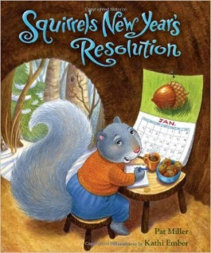

WALT: Can I think of a New Year’s resolution? WC: 4/1/21

WILF: I can think of my own idea to improve myself in 2021

I can draw a picture of my idea

I can copy my thinking

In the year 2021 my New Years Resolution will be that …

I am going to