Olly the Octopus has lost his suckers…Can you help him?

Can you say the words ‘All around the orange for letter ‘o’?
Can you count the octopuses’ 8 legs?
Can you count the correct number of suckers onto the tentacles? You can draw a sucker like this..
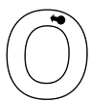

ctopus
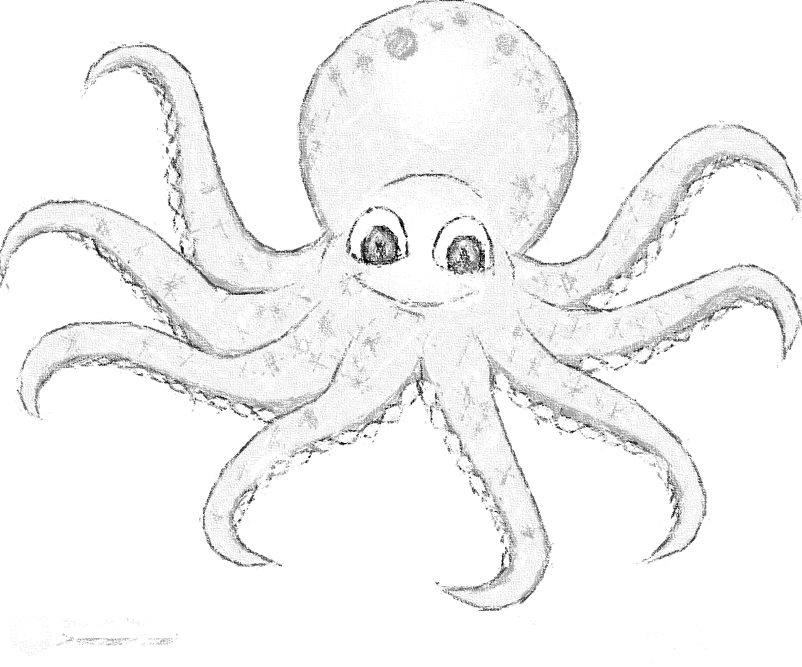
l
4
2
3
8
7
6
5

