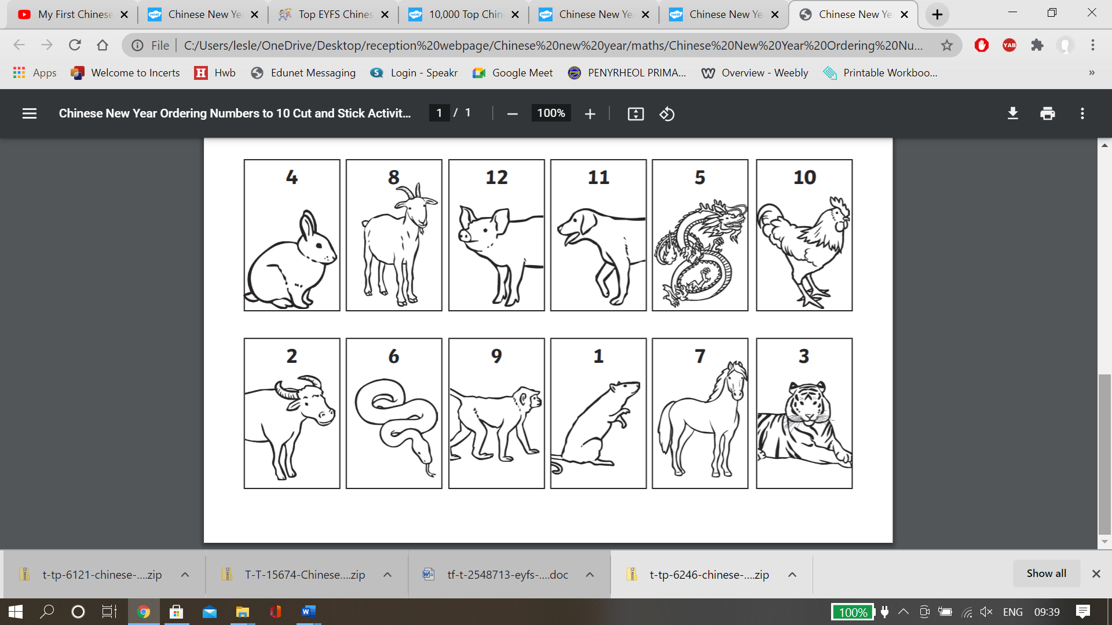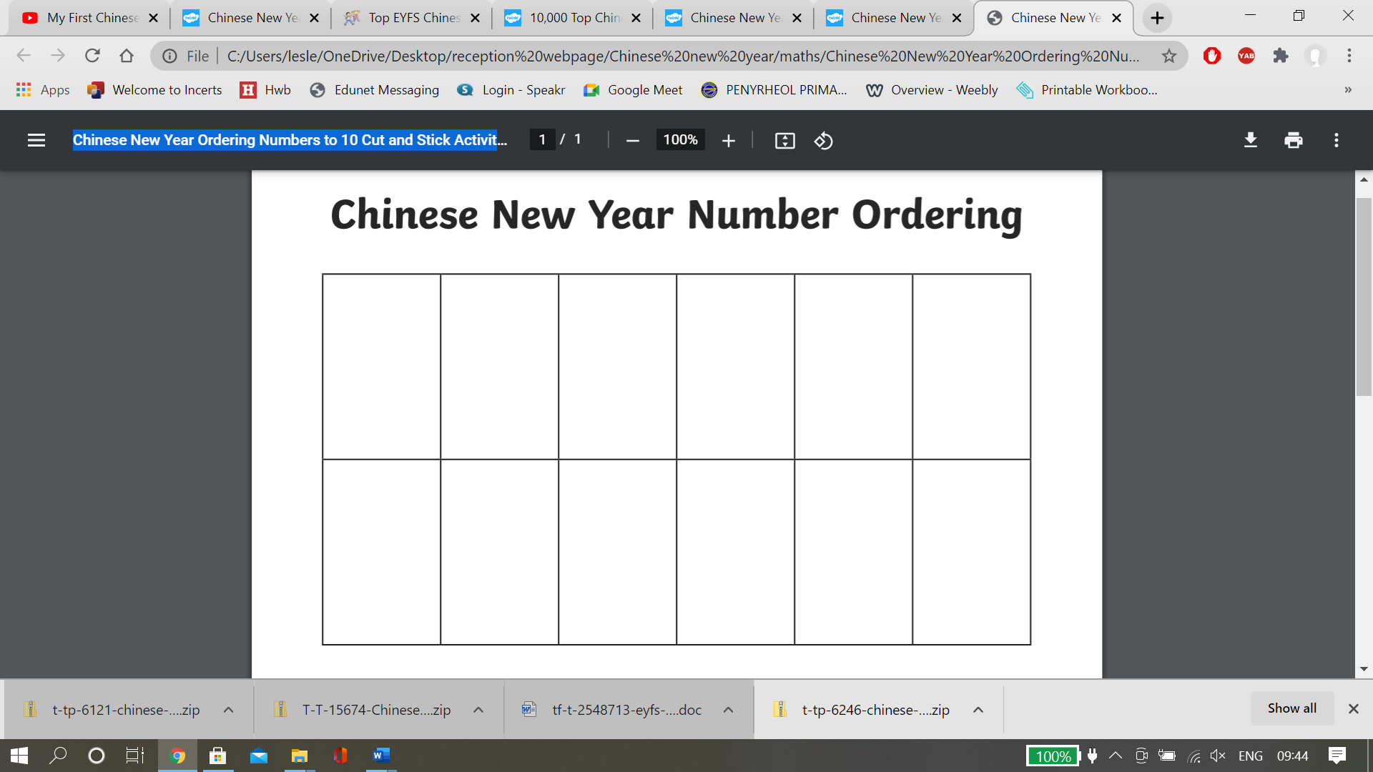

Listen to the story – ‘Chinese New Year’. Can you cut and stick the animal pictures in order from 1 to 12 to show the order in which the animals finished the race.