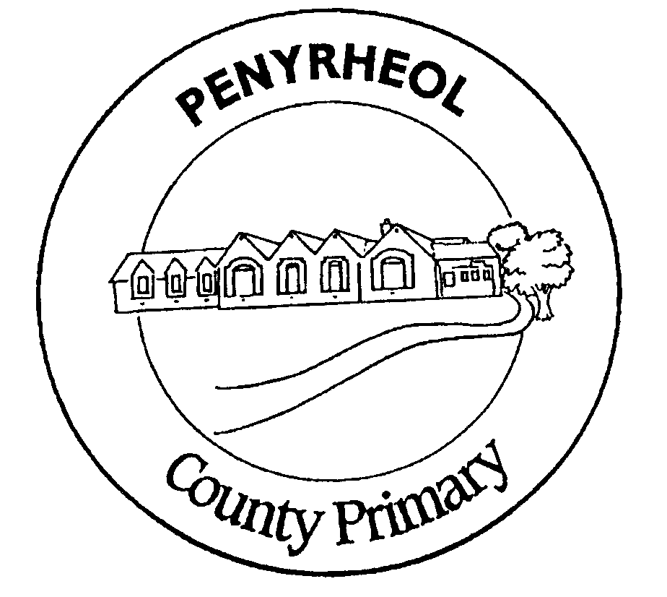
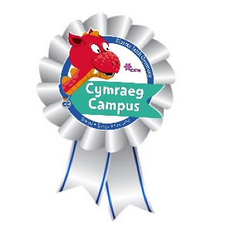
YSGOL GYNRADD PENYRHEOL
PENYRHEOL PRIMARY SCHOOL

Putting Children First
Plant yn Gyntaf

Putting children first to be ambitious and capable learners, ethical and informed citizens, enterprising and creative contributors and healthy, confident individuals.

Outdoor Learning Policy
2023 – 2024
The National Curriculum in Wales 2022 is organised around 4 Broad Purposes, 6 Areas of Learning and Experience and 3 Cross Curriculum Responsibilities.
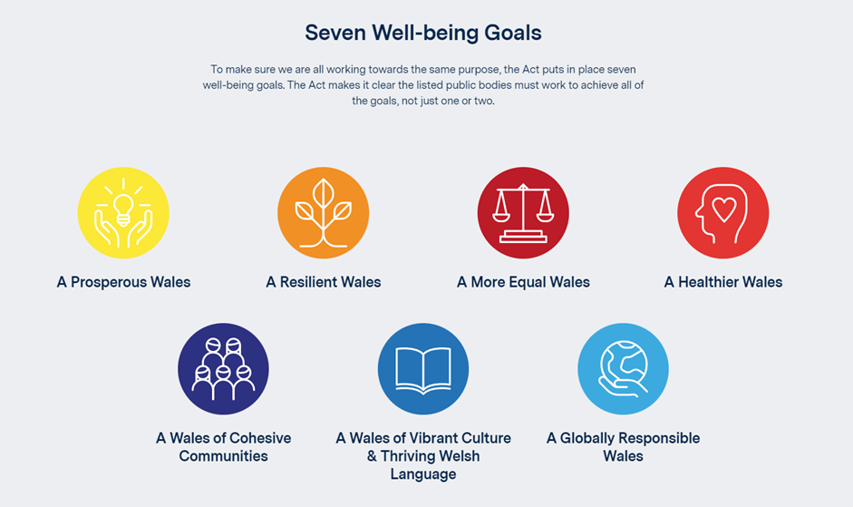

We are fully committed to working towards achieving the seven well-being goals identified in the Welsh Government Wellbeing of Future Generations Act 2015 Health and well-being is central to everything at Penyrheol Primary School.

The United Nations Convention on the Rights of the Child (UNCRC) is at the heart of our school’s planning, policies, practice and ethos. As a rights-respecting school we not only teach about children’s rights but also model rights and respect in all relationships – Linked to Articles 3, 7, 16 (CRC) All learning is also linked to the United Nations Sustainable Development Goals(SDG’s)

Date of Review: 28th June 2023

Curriculum for Penyrheol
Our Vision Ein Golwg ni
At Penyrheol we aim to develop lifelong, enthusiastic, innovative and creative learners who have the knowledge, skills and learning attributes that enable them to deal with whatever challenges lie ahead in a rapidly changing world.

The well-being of our pupils is at the heart of our curriculum and our children learn best through practical 'hands on' learning opportunities; these enable them to experience learning in a meaningful way that reflects their interest and needs. Children are encouraged to follow and explore their own questions and enquiries in a creative environment.

Our curriculum vision is rooted in Welsh values, culture and the Sustainable Development Goals in an authentic context relevant to the child. Children at Penyrheol have a voice and choice in their learning. Children know what they are good at and how to improve. We encourage a growth mindset, which focuses on fostering independence and resilience in an inclusive environment.

It has the development of literacy and numeracy at its core, alongside developing the attributes for children to be good learners, as these are the essential life skills for every child to be able to access future learning. Problem solving and thinking skills are through all areas of our curriculum design .

Introduction

The Sustainable Development Goals (SDGs) and the four broad purposes are at the heart of our school’s planning, policies, practice and ethos. As a rights-respecting school we not only teach about children’s rights but also model rights and respect in all relationships. However, we believe that ‘Enjoyment’ should be a right for every child also.

Children learn better when they are excited and engaged – but what excites and engages them best is truly excellent teaching; teaching that supports and challenges them to show them what they can do. When there is fun in what they are doing, they learn to love learning.

Our outdoor learning policy aims to foster children’s love of learning. At Penyrheol Primary, we believe that all children have the right to experience the unique and special experience of purposeful learning outdoors. We believe that it is important to enable children to use the outside environment as a context for learning across each of the AoLE’s
What do we mean by Outdoor Learning?

Outdoor Learning is a broad term that includes outdoor play [learning through play], forest school activities, environmental education, recreational and adventure activities, health and well-being and Active Journeys daily skills sessions including Cycling and Scootering.

Outdoor Learning does not have a clearly defined boundary, but it does have a common core. Outdoor learning can provide a dramatic contrast to the indoor classroom. There is strong evidence that good quality learning outside the classroom adds great value to classroom learning. It leads to a deeper understanding of concepts that span traditional subject boundaries which are frequently difficult to teach effectively using classroom methods alone.

First hand, high quality experience outdoors is powerful, motivating and can have tremendous impact and credibility. The results from outdoor learning can be instantaneous as well as active and practical and therefore impact on promoting positive behaviour and engagement as well as tapping into the learning styles of the more kinaesthetic learner.

Through skilled teaching, outdoor experiences readily become a stimulating source of fascination, personal growth and can lead to breakthroughs in learning. Active learning readily develops the learning skills of enquiry, experiment, feedback, reflection, review, communication, problem solving, an enterprising attitude and cooperative learning.

Outdoor Learning can help to bring learning alive. For that reason, the outdoors can have an impact on areas of the curriculum as diverse as imaginative writing and personal and social development. Outdoor learning also provides experiential opportunities allowing pupils to respond positively to opportunities, challenges and responsibilities, to manage risk and to cope with change.

Benefits of Outdoor Learning

- Outdoor learning helps to ensure that all children are successful learners enabling children to develop knowledge and skills in ways that add value to their everyday learning experiences.
- Outdoor learning enables children to be confident individuals and impacts positively upon young children’s attitudes and beliefs.
- Outdoor learning contributes towards creating independent learners with high self-esteem and self-sufficiency.
- Outdoor learning can have a positive impact upon children’s behaviour.
- Outdoor learning contributes towards children’s understanding of the importance of developing a Healthy lifestyle.
- Outdoor learning has a positive impact upon children’s personal and social development. It can also bring about community cohesion and allow children to develop as responsible citizens better placed to make a positive contribution to their wider community. It can create pride in the school and wider community and promote community involvement, renewing children’s pride and creating a sense of belonging and responsibility.
- It raises learners’ attainment, promotes and strengthens communication skills, teamwork and sense of cohesion.
- There is clear evidence that boys respond more positively and are more active in their learning in an outdoor environment.

Aims and Objectives

- To raise the profile of Outdoor Learning.
- To empower children to take ownership of their learning, allowing their minds and bodies to thrive
- To encourage children to develop the skills to solve problems, developing resilient and reflective learners.
- To develop skills of communication, cooperation and collaborative learning.
- To provide a challenging, safe and secure environment within which children can take and manage risks.
- To encourage close links with parents and the school in celebrating our outdoor space and the rich learning that can take place within it.
- To encourage children to care for their environment.

Health and Safety

At Penyrheol, staff will support children in taking risks within a safe and secure environment. Pupils will be taught to manage risks. It is important to ensure that the outdoor environment offers challenges and teaches the children how to be safe and aware of others. Staff will take every opportunity to take learning outdoors and teachers will assess risk.

In the first instance the school’s policies relating to Health and Safety and Risk Assessment should be referred to and applied prior to any outdoor learning activity that may require additional support beyond the reasonable activities one would normally apply within the classroom. It is also important that the school applies robust safety measures to effectively manage and minimise risks. It is equally important, however, that all involved, including parents acknowledge that a degree of residual risk remains. We therefore discuss with parents their views regarding outdoor learning – and the degrees of risk that apply to the varying activities.

Our children are taught to manage risks regarding outdoor learning. All pupils are regularly reminded about the importance of staying safe and of keeping themselves and members of the school community safe.

There is a shared understanding of how pupils safeguard themselves and others when undertaking outdoor learning. Outdoor Learning is an important part of our learning journey.
The following expectations are understood by all pupils:
- We must uphold our school expectation to stay safe at all times when we participate in outdoor learning.
- We must never walk across the car park/vehicle access area.
- We must stay with our group.
- We must always ensure that we close all doors and gates behind us.
- We must never open doors or gates to visitors.
- We must be sensible and ensure that we achieve our learning objectives.
- Only our teachers can open doors and padlocked gates.

Monitoring and Evaluation
Assessment of the children’s learning will be valued equally indoors and outdoors and should be part of the same process.

Policy Review
This policy should be considered alongside other relevant policies. It will be reviewed by the governing body as part of its schedule of policy review.

Managing the delivery of Outdoor Learning
Through the monitoring of teaching and learning e.g. planning meetings, learning walks, listening to learners’ exercises, classroom observation, teachers’ self-evaluations, summative assessment records and other school procedures we closely monitor the use of outdoor learning as a key element of the learning experience at Penyrheol Primary School.

We provide INSET and ADDS training and support and ongoing professional development to enable staff to feel confident developing the expertise or knowledge base to adapt their practice to include opportunities for learning beyond the confines of the classroom.

We encourage parents and children to be more resilient about weather conditions. All families are encouraged to ensure their child has outdoor clothing and footwear. School also provides waterproof clothing and footwear to ensure equity for all children.

Our Commitment to Outdoor Learning
We have magnificent grounds at Penyrheol Primary School and have recently invested in the development of additional outdoor learning resources for use in the zoned outdoor learning areas across the site and the use of the Forest Garden and the Polytunnel with Mrs Jenny Chisholm.

At Penyrheol Primary, we have developed strong links with staff and resources at a range of additional off-site areas. These include Sustrans Active Travel and Nature Days in Reynoldston , City and county of Swansea Melyn Mynych Pump Track and Cycle Path.

Pupils also have many opportunities to visit a range of natural local resources within close walking distance of the school. Plans are also well underway to work in partnership with Llannant Farm to create a Forest Garden allotment plot for all classes and wider stakeholders to share in the promotion of biodiversity and cultivation of produce.

We will continue to build upon these for the benefit of all of our children. We know that the pace of learning can be enhanced by using the outdoors and that children who may find the classroom too constraining will perform and behave better outdoors, reducing the time spent on explanation and behaviour management. There is clear evidence that boys in particular, are more engaged in their learning in an outdoor environment. The school will communicate the benefits to parents and the wider community of outdoor learning so that there is a greater understanding of its value and importance and provide a greater awareness of the safety standards the school adopts.

Where should Outdoor Learning take place?

The school grounds
We are exceptionally lucky to have extensive grounds which offer excellent opportunities for both formal and informal learning and play. School buildings can also provide a useful resource for learning about energy use and waste for example – tying in well with the Eco school programme. We endeavour to have ecology and sustainability as an integrated theme throughout our curriculum and evident in all aspects of the life and work of the school, in exactly the same way that Health promotion should permeate our school.

The local environment
The locality around school harbours a wealth of opportunities within relatively accessible distance. Staff and learners can develop their skills to explore their local environment. We have very strong links with a range of community groups are always looking for opportunities to take the children out into the community.

Places further afield.
We actively encourage all teachers to plan opportunities for children to engage in learning beyond the school grounds. Each year group has a planned programme of educational visits which complement and extend every unit of learning. These also support our work in developing enterprise education and our desire to develop more business links. These are planned into all aspects of the curriculum and, by taking learners beyond their familiar environment, stimulate their curiosity and imagination and motivate children in a powerful way.

Residential places
Staying away from home is a powerful way of developing key life skills, building confidence, self-esteem, communication and team working, for example. For instance, through staying at outdoor and adventure centres such as Llangrannog Outdoor Education Centres, provides children with an opportunity to widen their range of experiences and find new skills and interests in which they may excel.

Children with Additional Needs
Equity of opportunity to outdoor learning is a primary focus and accessibility to areas is given the highest priority. Strong links with Surfability Wales ensure appropriate support is secured to enable all children to fully participate in Surf Lifesaving session each year. Learning in the outdoors can also overlap with the teaching of life skills. At Penyrheol Primary we will be supporting our children by using life skills training as a motivational tool, encouraging our pupils to use a range of interdisciplinary skills to meet certain targets and objectives.

More able Children
Outdoor learning offers opportunities for personal research and develop a. enhanced understanding of their place in the natural world, further developing an understanding of learning processes, enquiry and thinking skills that deepen and enrich subject learning.
The above issues allow opportunities to access discussion on a moral code, ethics, humanity, sustainability, science in its widest sense, problems pertaining to globalisation and philosophical enquiry, for example. Outdoor Learning acts as a bridge to higher order learning and opportunities to challenge misconceptions and ways of thinking.

Disability Discrimination, Equality and fairness
The school has guidelines in line with the Equality Act 2010 and consistently works hard to take account of and include the views of parents and children who have a disability. These are used to make any necessary changes to our school policies, promoting positive behaviour/discipline procedures and other aspects of the life and work of our school.

