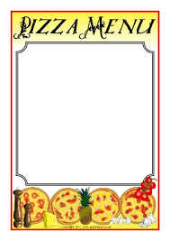

**You can make your pizza out of any materials you like. Card, paper, you can draw it, paint a pizza, use play dough. Your choice!**

**Can you design your own pizza?**

Think about what you like to eat on a pizza. If you don’t like pizza, make a pizza for a friend. What would they like to eat?

You can make your pizza out of any materials you like.