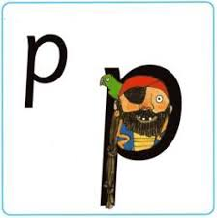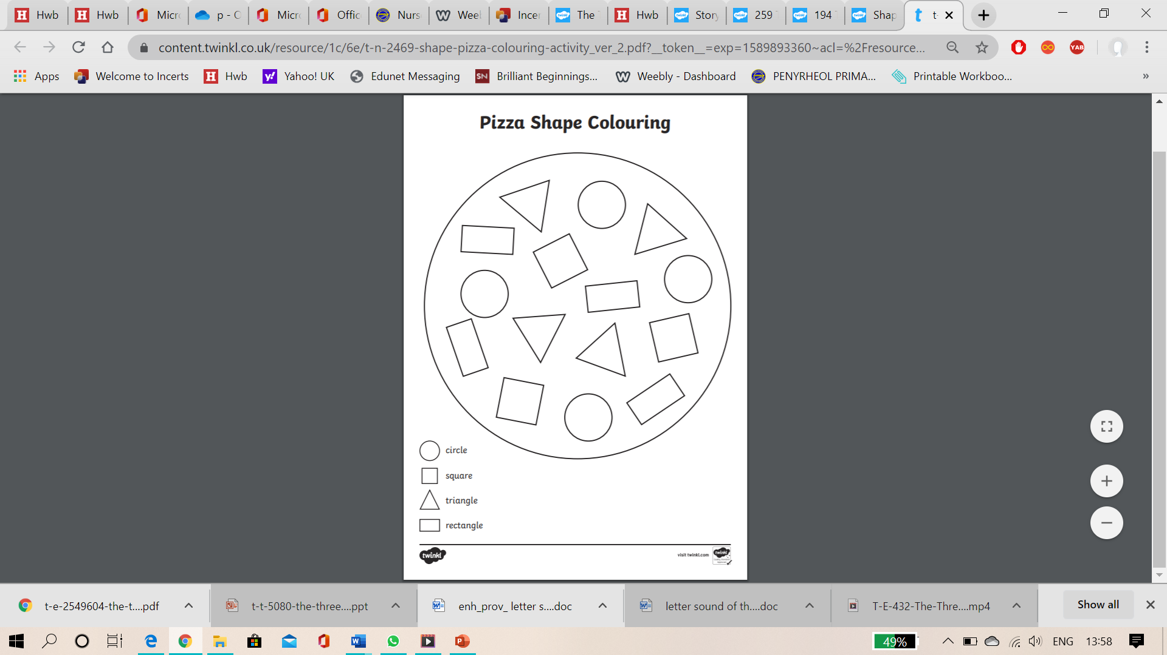

Can you name the shapes,? Colour them in the correct colours and count how many there are of each shape?