Point of view:
Watch the clip again and pause at three moments of significance for the boy (your choice). For each event, write a brief explanation of what is happening in that moment and then complete the speech bubble next to each with what you think the boy would say if given the chance to share his thoughts

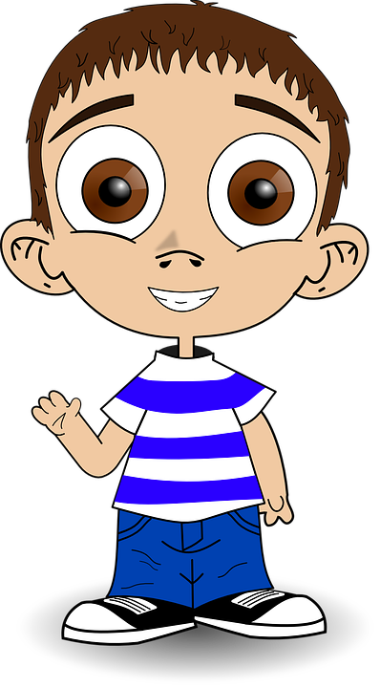
Now can you use speech marks to write what the boys has said. Think about how he might say it. Is her frightened, worried or happy?

