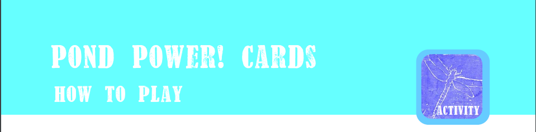
This card game is based on top trumps. It can be played in groups.
Each creature has scores out of 10 in each of the categories.

Before you play:
- Photocopy the three pages of cards as many times as you like. More for a bigger group.
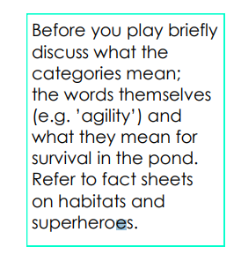
- Cut them out.
- You could stick pages to card for strength before cutting
(or kids can!)

Any number of people can play.
- Shuffle and deal all the cards face down.
- Each player holds their cards with only the top card facing up.
- The first player turns their top card and chooses a category. They say the category and the score out loud. E.g. if their creature has an agility of 9 they should say “Agility 9”.
- The other players read out what their animal scores in that category.
- The player with the highest value wins all the cards from that ‘round’ and places them at the bottom of their pile.
- It is then their turn again to choose a score from the next card.
- In case of a draw where 2 or more cards have the same chosen score, place all the cards in the middle. The next time there is a winner of a round they take these middle cards too.
- The winner of the game holds all the cards but you can also put a time on the game and see who has the most when time is up. Or stop play when someone runs out of pond life for their ecosystem!
After pond dipping why not add to these cards by making your own with creatures you’ve seen.

