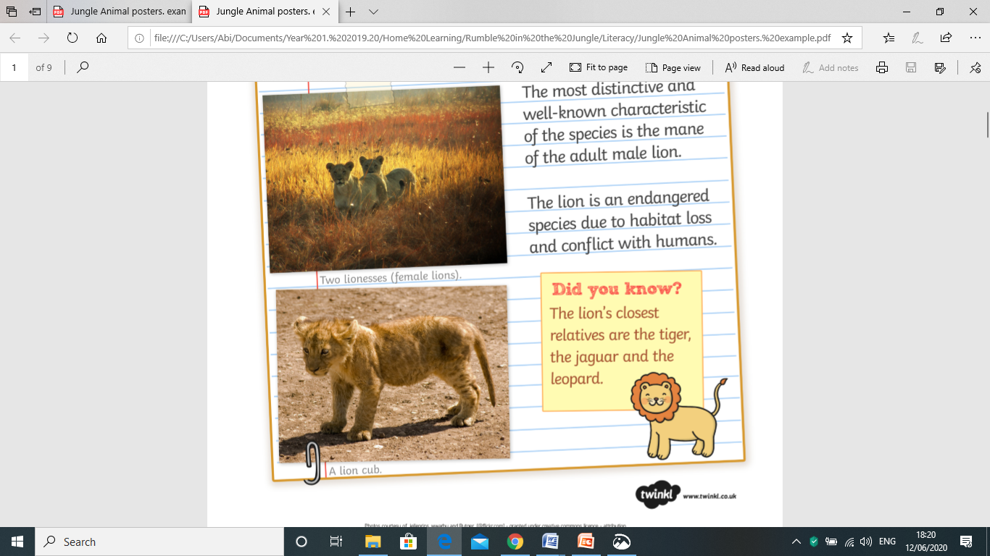

*Labelled diagram*

**Fun facts**

**I like to eat ...**

**Habitat**