
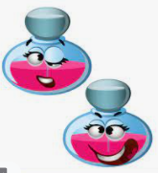

Are you feeling miserable and downhearted? If so, do not despair. Help is at hand. Laughter is the best medicine. Follow this recipe, drink this potion and soon you will become the most jovial and fun-loving person.

Ingredients
200g of coca cola
3 mint leaves
One strand of hair from a smiling baby
15g of laughing gas
Baking powder
1 Kiwi
Your best joke

Method
- First, pour the coca cola into a large jug.
- Then, chop mint leaves finely and drop them into the jug.
- Now, place the baby hair into the mixture so it floats on top.
- Stir slowly.
- Next, add 15g of laughing gas (no more, no less).
- Heat the mixture, then stir vigorously.
- Shave your kiwi and scatter hair over the surface of your potion.
- Stir quickly and apply a high heat.
- Laugh loudly and uncontrollably.
- Add a sprinkle of baking powder.
- Finally, tell your best joke out loud and guzzle down immediately.
Helpful tips:
The potion must be stirred slowly at first otherwise the mint leaf properties are damaged. Also, when telling your joke, your potion will bubble loudly which is a sign that the joke was funny. If your potion does not bubble, you must tell another joke.

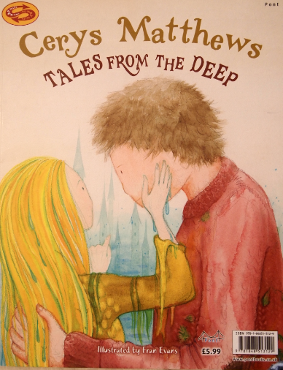
Having read the Welsh tale Myddfai Magic, you can see how quickly Gwyn fell in love with the lady of the lake. It was a love like no other. However, his heart was broken when she returned to the bottom of the lake. Can you create a recipe for a potion that mends a broken heart? Use my laughing potion recipe above to copy my layout. Below is also a layout that you can copy and make into your own.

TITLE OF POTION RECIPE

Short introduction about what the potion will cure,help with or do.

Ingredients:

Method with numbered steps:

Conclusion with helpful tips

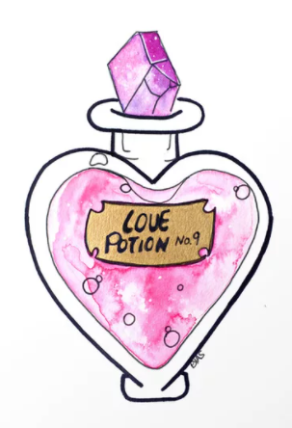

Below are bullet points which tell you ‘What I am Looking for’ (WILF) in your broken heart potion recipe. You must tick them all off so you know you have been successful and made the best recipe possible.

You MUST include:

- Heading
- Introduction to potion
- Sub heading – ingredients/ method
- Bullet points/ numbered steps
- Time connectives (first, then, next, now, after that etc.)
- Verbs (bossy words like pour, cut, chop, sprinkle etc. )
- Adverbs (words explaining how something is done like slowly, carefully, vigorously)
- Helpful tips
- Draw diagrams

