Can you recognise our letter sound qu?
Can you think of 3 questions you would like to ask the queen?

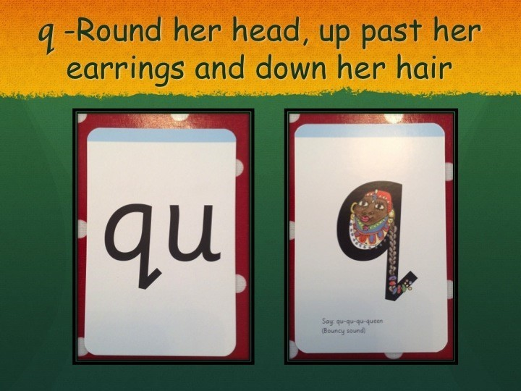

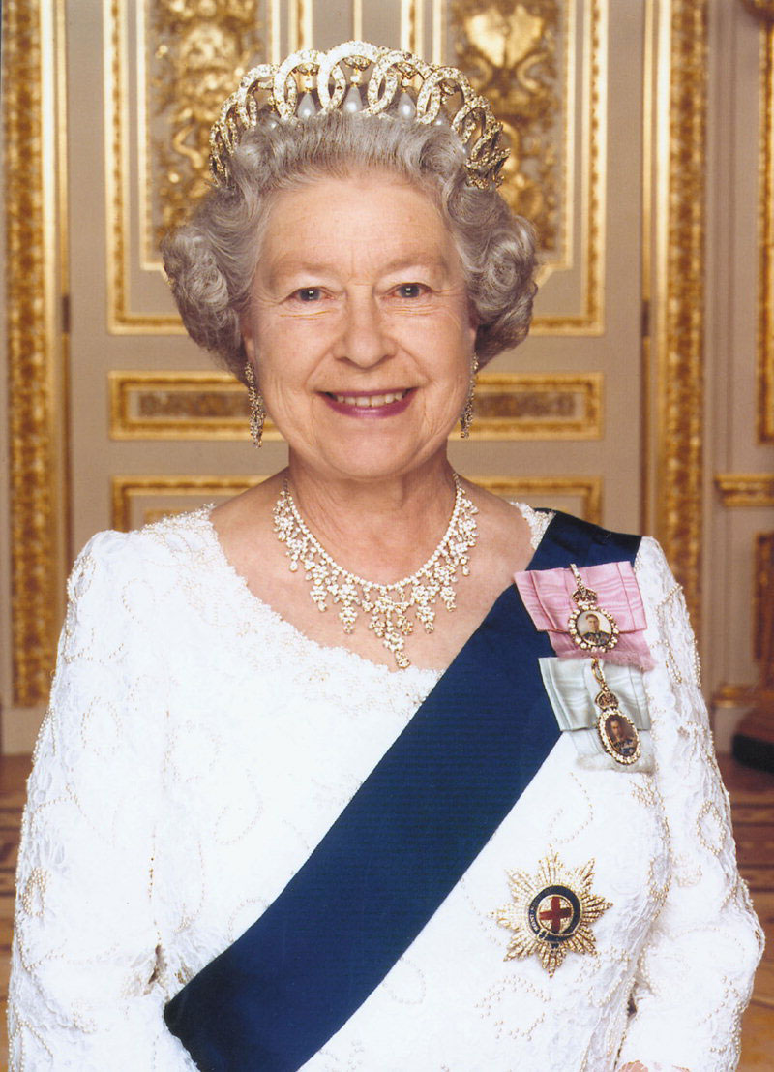

Can you draw a picture of a queen?

