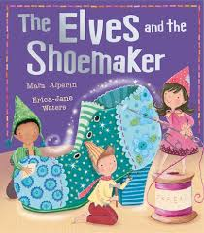
Pepper is always asking questions!
See if you can answer these:

1. What kind of person was the shoemaker?

2. Can you describe the three elves?

3. The shoemaker lives in a house with a workshop and a shop. Can you draw it? (You can use a separate sheet of paper)

4. At the beginning of the story, why was the shoemaker poor?

5. After his supper of bread and jam, the shoemaker goes to his workshop.
Which words suggest that he is feeling sad?

6. Write your own a question about the story and ask someone in your house to answer it?

