The Truth about Trolls
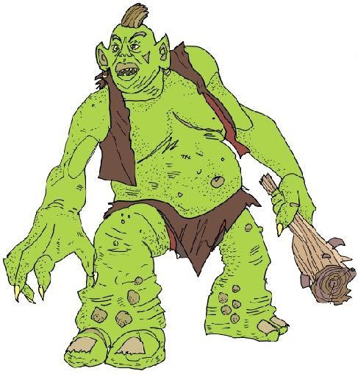
Many people believe trolls are angry, mean beasts that terrify goats and people. However, this is not true. Here is the truth about trolls.
What do trolls look like?
Like the ogre, trolls are huge. They look fierce and ugly but to another troll they are kind and beautiful. The adult troll has small, beady eyes, a bulbous, warty nose and sharp, yellow teeth. Most trolls have long, curly horns on their heads similar to a goat. Interestingly, a few trolls do not have any horns at all. No one knows why.
Where do trolls live?
Trolls are usually found in very cold countries like Iceland. They make
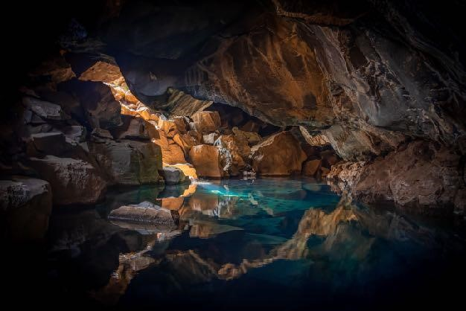
their homes in caves near volcanoes which provide both warmth and shelter. They live peacefully in small family groups, hidden away from people. One troll, who was very grumpy, lived alone under a wooden bridge. Because he bullied the local goats, he gave all trolls a very bad name.

Photo by Michael Behrens on Unsplash

What do trolls eat?
Trolls enjoy eating all types of seafood. Trolls fish in total darkness so that they are not seen by anyone. They mostly eat their food raw. Sometimes, when the volcanoes have erupted, they cook their food on the hot rocks. In addition, they gather large mushrooms and dig up juicy roots that grow in the forest. Surprisingly, goats are not on the menu!
Did you know?
Amazingly, trolls like to have fun. They love singing and dancing. When they sing, it sounds like a rumble of thunder. When they dance, it feels like an earthquake. Sadly, because of the troll that upset the goats, all trolls now hide away from view.
They can still be seen, though, if you look really hard and believe. The rocks here are actually just sleeping trolls!
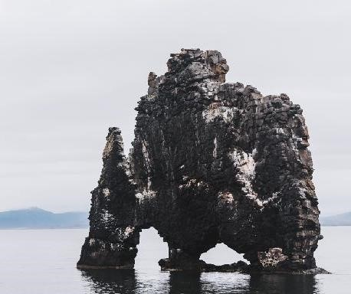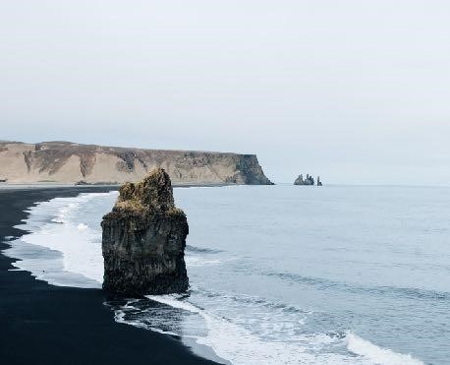

Professor Folklore
‘Friend of the Troll’

Glossary
Here’s some help with the tricky technical vocabulary:

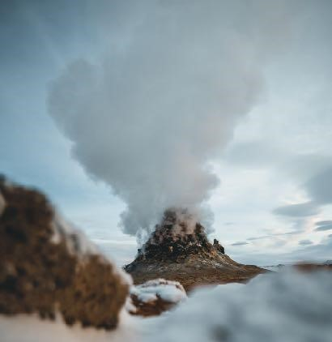
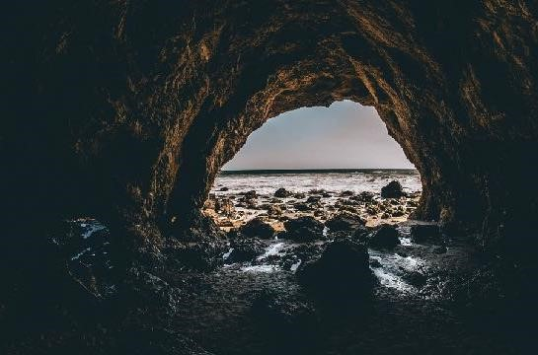
earthquake: Sudden shaking of the ground when the Earth’s surface moves. Can cause terrible destruction.
volcano: a hole in the Earth, usually a mountain, where very hot, molten rock (magma) and hot gas from the centre of the Earth erupts – can cause terrible destruction erupt: the action that happens when a volcano spits out hot molten rock (magma) and gas – can cause terrible destruction

cave: Hole or space in rock big enough for a person to go into.

Further Information on Earthquakes from BBC Bitesize https://www.bbc.co.uk/bitesize/topics/z849q6f/articles/zj89t39 Further Information on Volcanoes from BBC Bitesize
https://www.bbc.co.uk/bitesize/topics/z849q6f/articles/zd9cxyc

