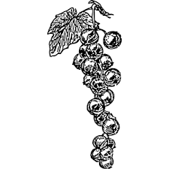

Notes:

Ingredients:

Instructions:

Serves: ___________ Prep Time: __________

From the  of: ________________________

Recipe: ______________