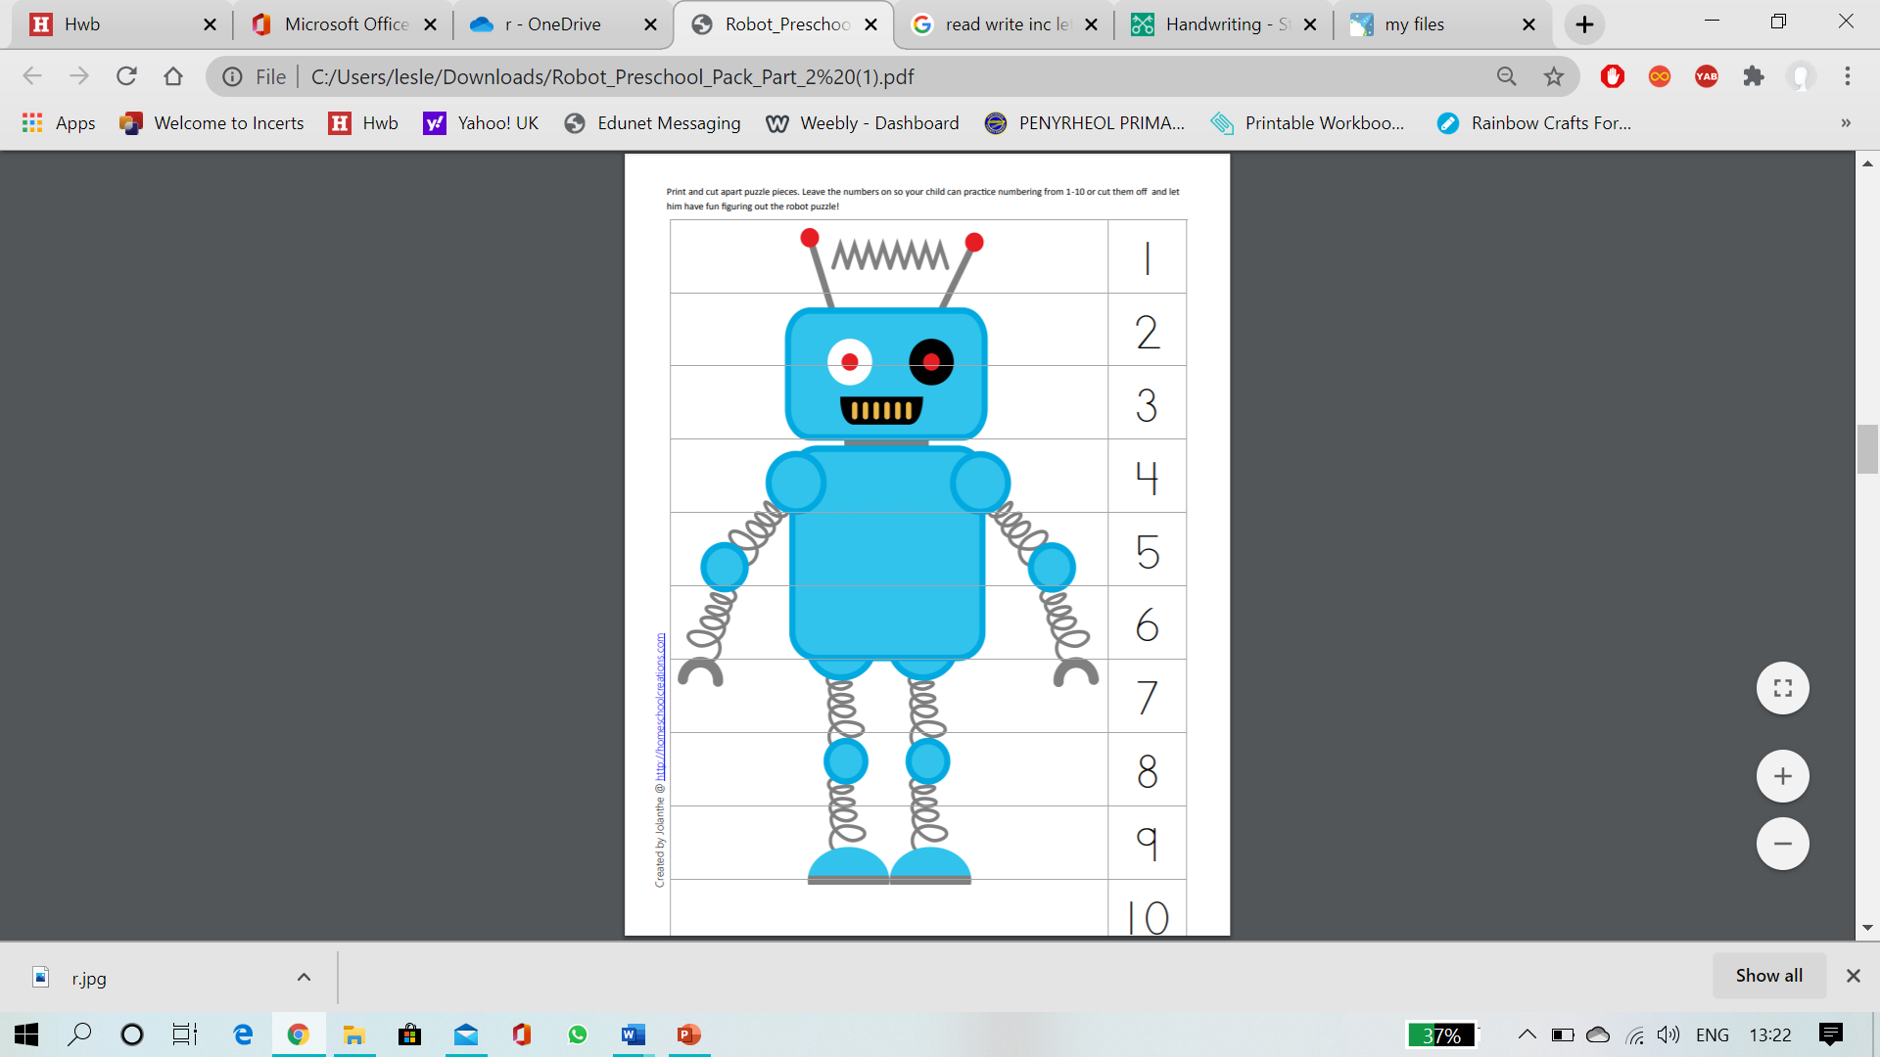

Print and cut apart puzzle pieces. Leave the numbers on so your child can practice numbering 1-10.