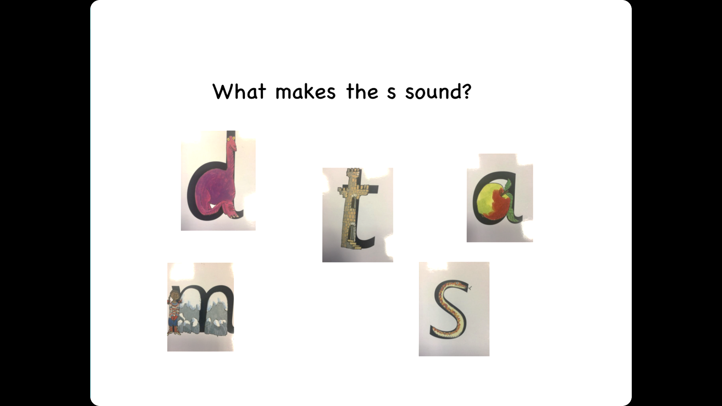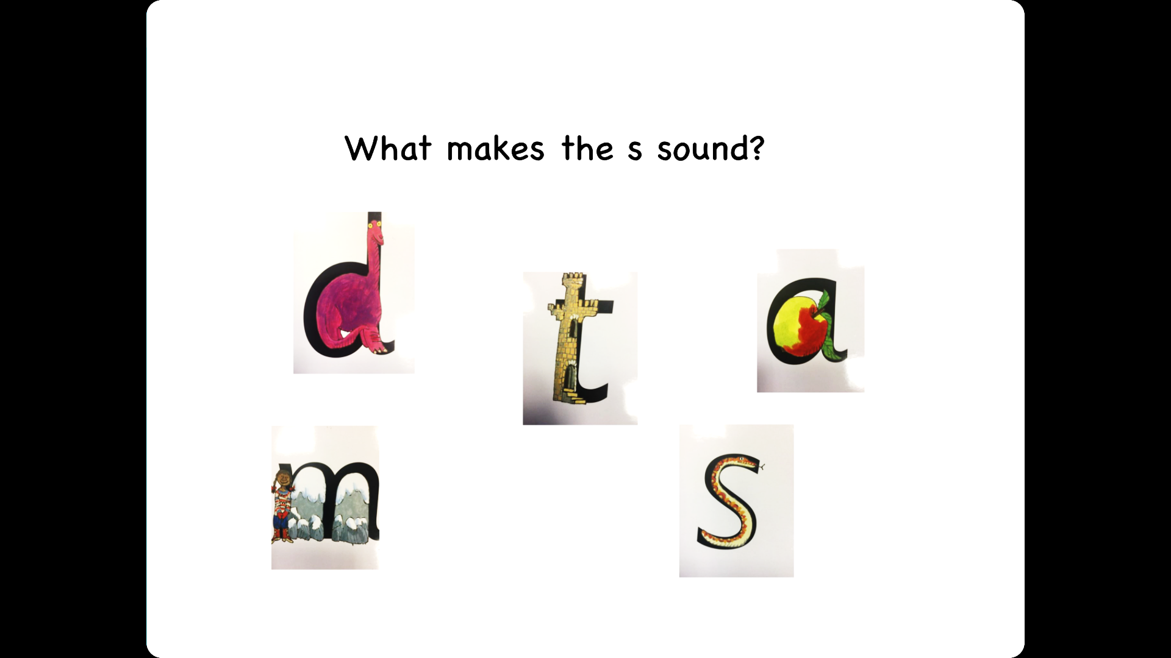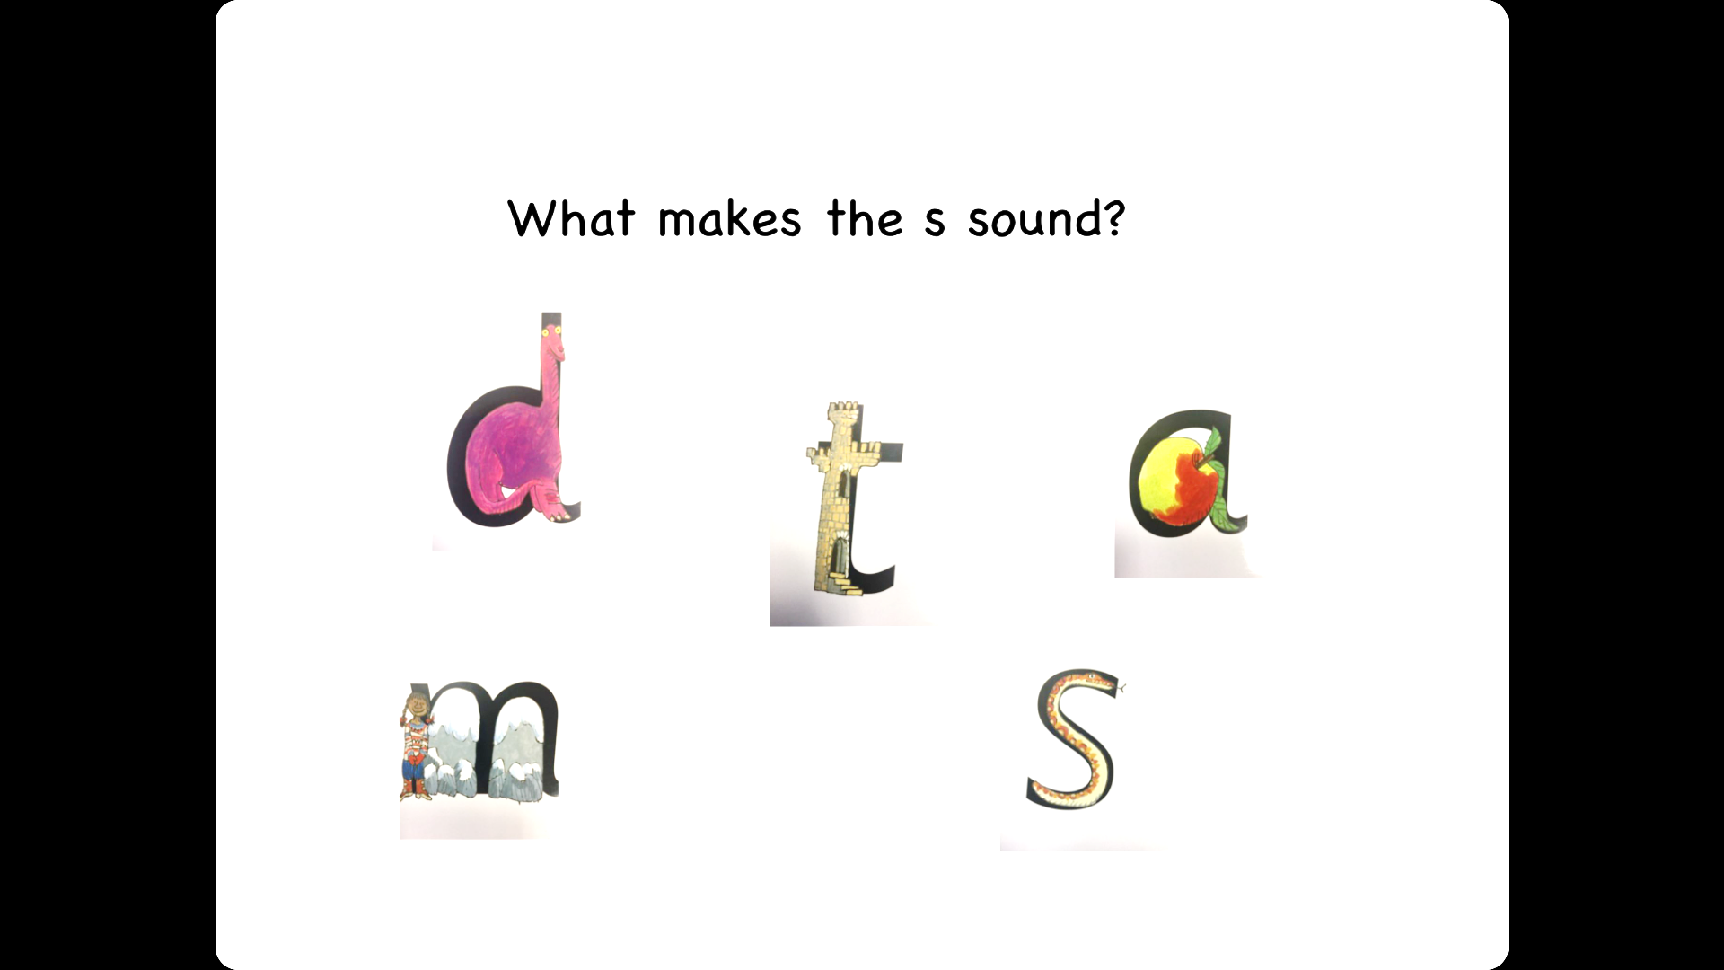

WALT: Can I say and record initial letter sounds correctly? W/C 4-1-21

WILF: I can link spoken sounds to letters m, a, s, d, t

I can form the letters we have learnt before Christmas.

I can isolate and identify sounds in spoken words



I can think of words beginning with:-