See Think Wonder
What do you see?

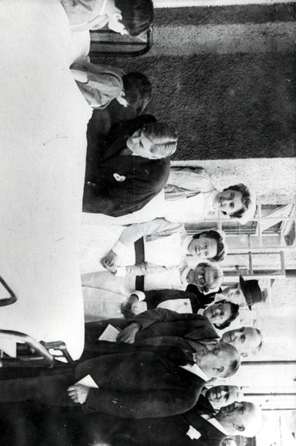

What are your thoughts and feelings? | What do you wonder? (write some questions)

