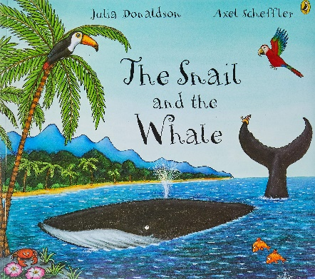
Cut out the words
to make 2 sentence.
Write 3 more sentence about the story.
Remember: capital letters, full stops, finger gaps and writing sitting on the line.

