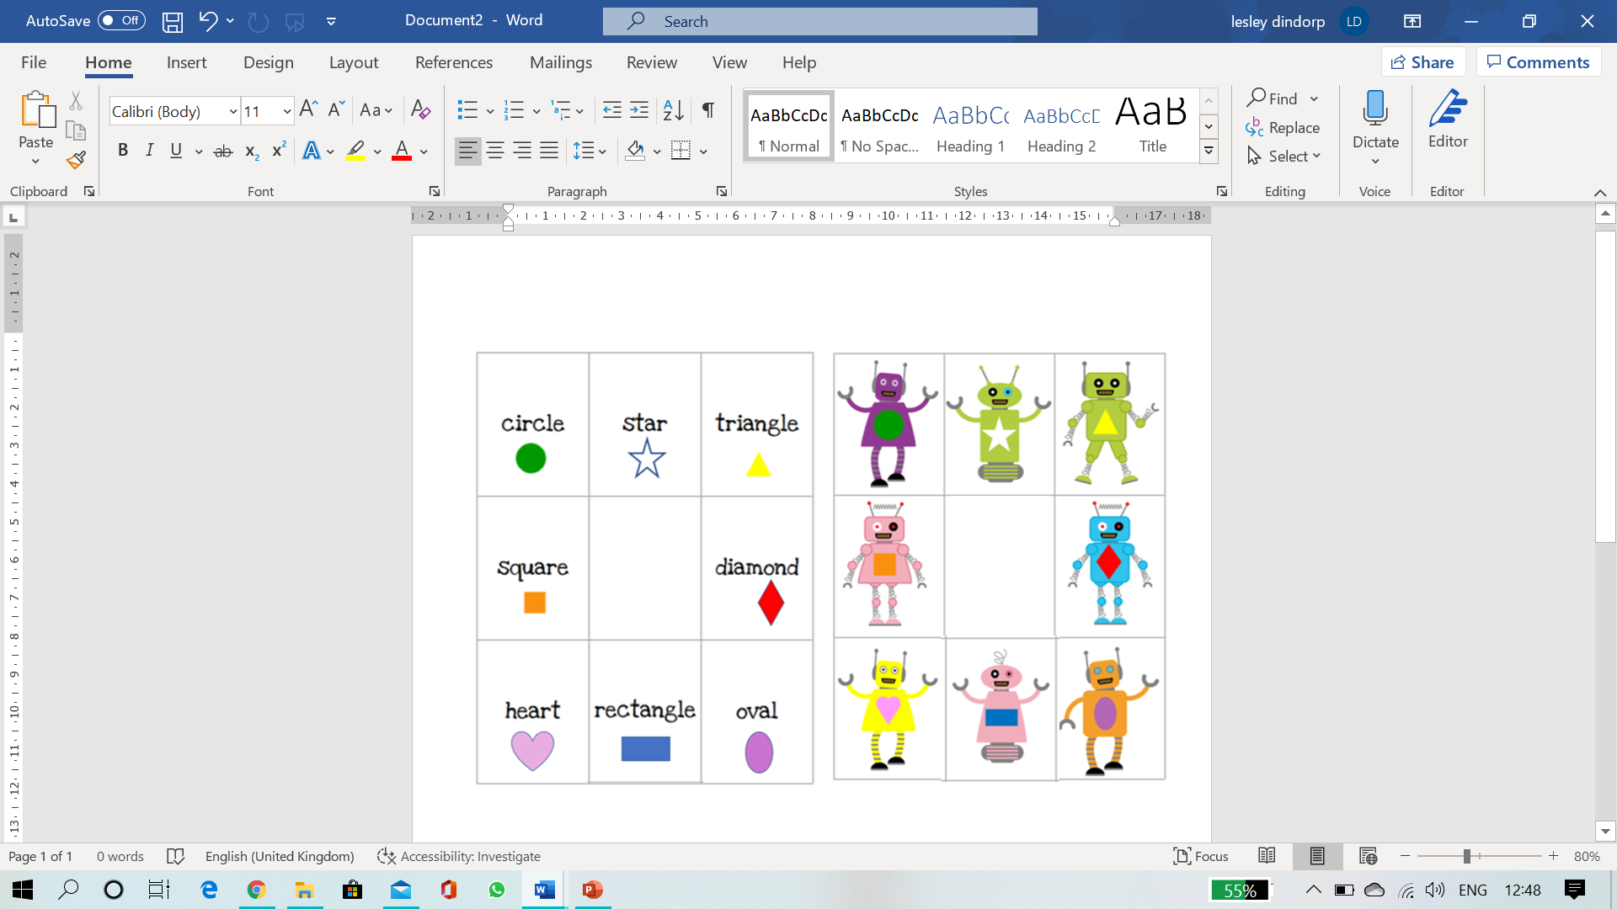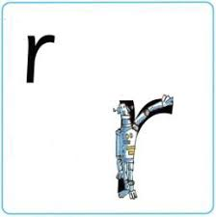

We are learning the letter sound ‘r’ this week. ‘Down the robots back and curl over his arm.’

Can you cut out the robots and match them to the correct shape. Their shapes are on their bodies.