Mouse has a pile of conkers. He wants to give half of them to the Gruffalo and half of them to the fox. Can you help to make two piles of conkers and say when you have the same number in each pile? You can replace the conkers with any other object. (Cars, marbles, smarties etc).

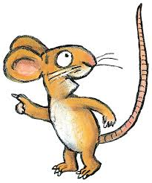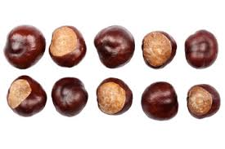First share 10 objects

Next share 12 objects

Then share 14 objects

Now try sharing 16 objects

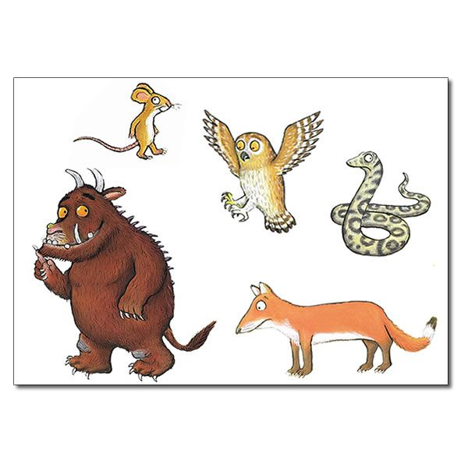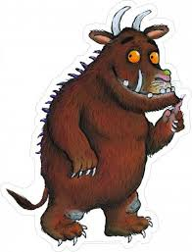Last share 20 objects