Should Pluto be A Planet?
Introduction:
Pluto used to be known as the smallest planet in our solar system, and the furthest planet from the sun. Pluto was discovered in 1930 by Clyde Tombaugh, an American astronomer. Pluto is over 5.8 billion km (3.6 billion miles) away, and it takes Pluto 248 years to orbit the sun. Following years of debate, and the 2005 discovery of Eris, a distant object even larger than Pluto, the IAU stripped Pluto of its planetary status. So, should Pluto be a planet ?

Scroll through the document to begin the three tasks:

Task 1 – sorting arguments
Task 2 – planning your discussion
Task 3 – writing up a discussion
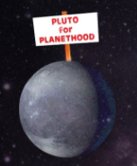
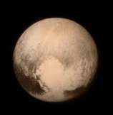

TASK 1
These statements are mixed up- can you sort them into arguments for and against the questions Should Pluto be a planet?
- Although known as a dwarf planet, it is still a type of planet.
- Pluto didn’t meet the planet criteria that the International Astronomical Union stated.
- Pluto is so small, smaller than Earth’s moon so it can’t be known as a planet.
- Pluto orbits the sun which planets do
- Information is updated and things constantly change in the future, so renaming Pluto as a dwarf planet is just changing with the times.
- Although Pluto orbits the sun, its path changes unlike the other planets which have consistent orbits.
- Pluto has a spherical shape like the other planets.
- Pluto used to be a planet and many people have already learned that fact so changing it now is confusing.
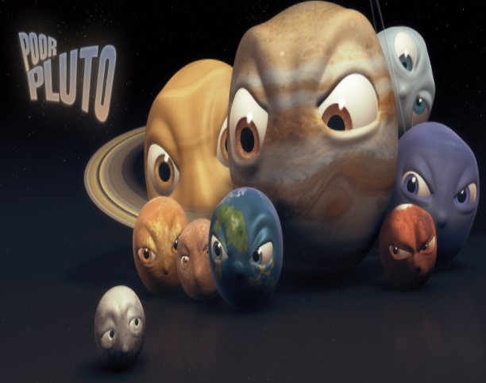

TASK 2
Using the arguments above choose three and place them in the correct boxes

Arguments for
Many people believe that.. | Firstly, the main argument is that
Pluto should be named a planet and not be stripped of its planetary status | …
Additonally, | Furthermore,
… | …

Arguments against
On the other hand, | Many astronomers suggest
Some scientists claim that Pluto does not deserve to be known as a planet anymore. | …
Moreover, | In addition,
… | …

TASK 3

Now you have planned your discussion in task 2, can you write out your discussion neatly, using your best joined up handwriting.
Use paragraphs –
-Your first paragraph must include arguments for (copy out the sentences from table 1 in task 2)
-Your second paragraph must include arguments against ( copy out the sentences from table 2 in task 2)
-Finish your work with a final paragraph stating your own opinion .
E.g.
Overall,
In conclusion, I believe that Pluto should/shouldn’t be known as a planet because ….

