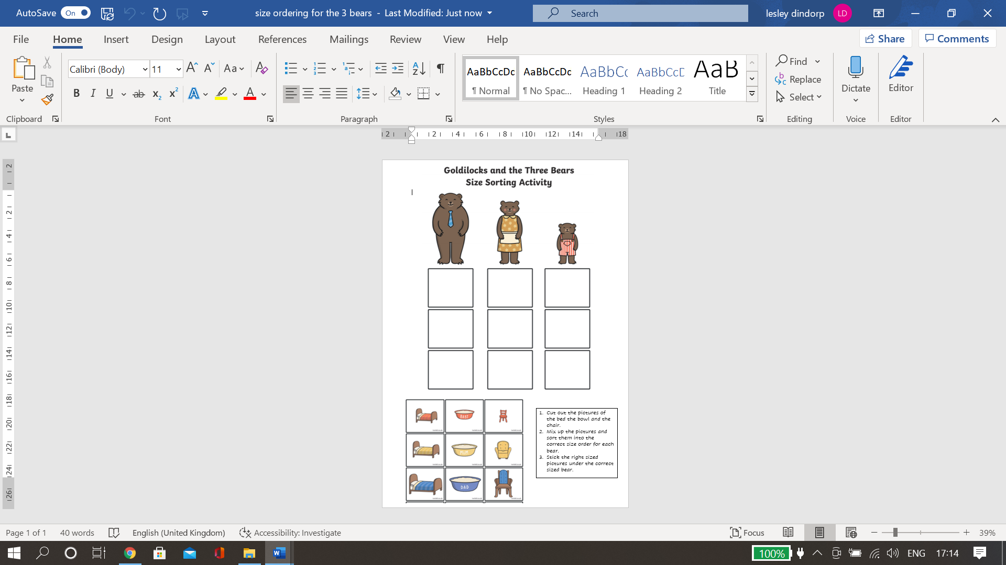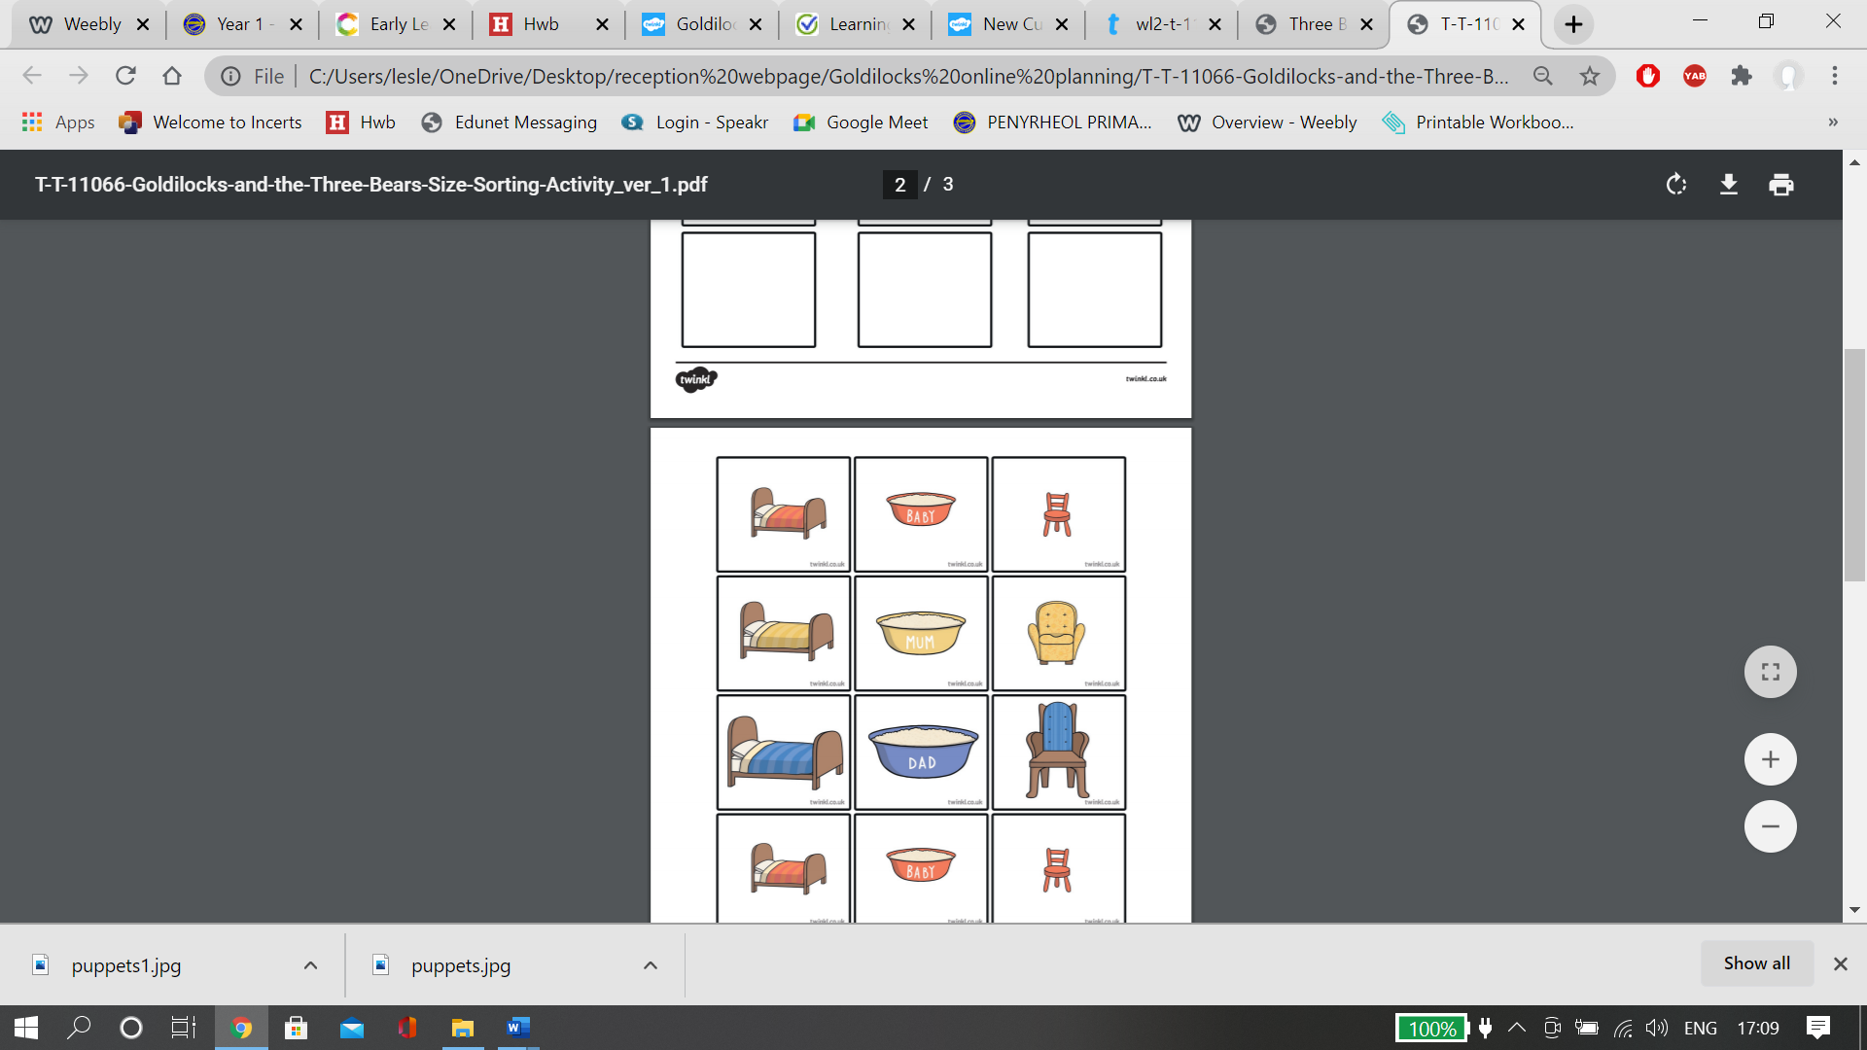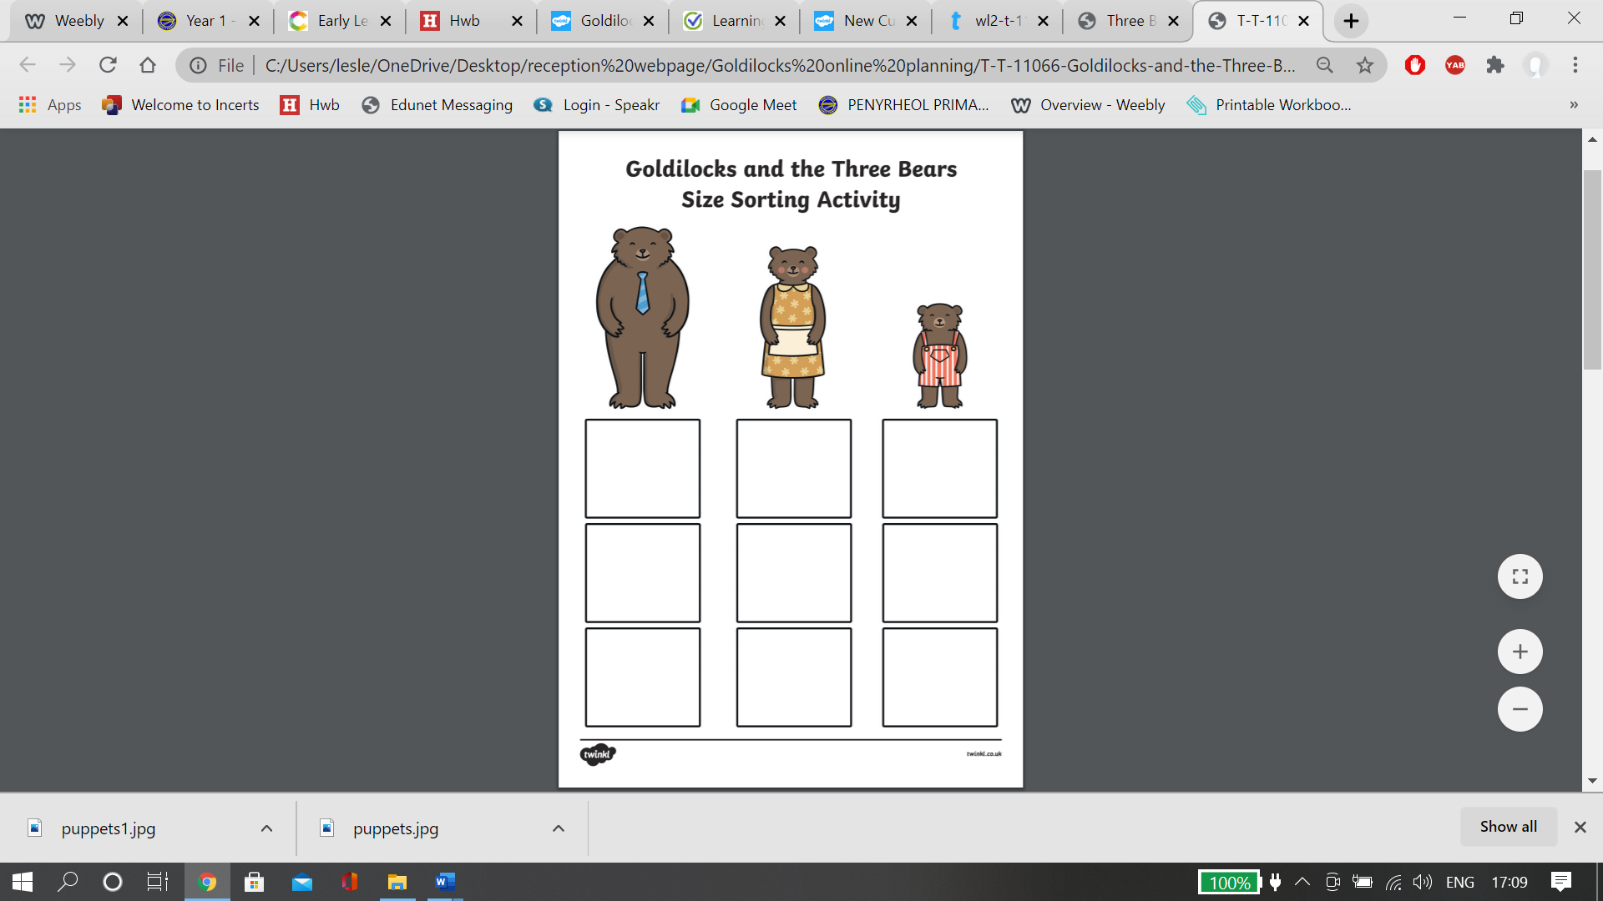

1. Cut out the pictures of the bed the bowl and the chair.
2. Mix up the pictures and sort them into the correct size order for each bear.
3. Stick the right sized pictures under the correct sized bear.