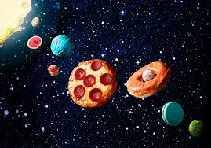
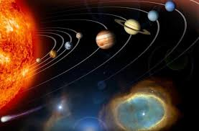
Space activities

Research | Design! | Solar system fact hunt | Get creative!
Research our solar system.  How many planets are there?  What are they called?  What are they like?  Use the internet to find out facts.  Create an information poster You could do one for each planet or one for all.  How about a PowerPoint presentation? | Design a new planet a new planet.  Think about  What will it look like?  Who lives there?  Colour?  Signs of life?  What is it made of?  I have shared a worksheet the website. | Complete the fact hunt sheet on website. | Design and make a space mobile.  See ideas below… lots more online.
 |  | Astronaut
watch the video clip
https://www.bbc.co.uk/bitesize/clips/zjbvr82
https://www.bbc.co.uk/bitesize/clips/zyw8q6f

look below for astronaut wanted poster below.
Write your own application to become an astronaut
 | Constellations | Rocket | Fruit solar system
 | Look at powerpoint on website  https://www.kcedventures.com/blog/astronomy-activities-for-kids-books-about-the-stars  Now create your own constellations | Create your own space water rocket.  See website for instructions | Create a fruit solar system.  See below for instructions
Mindfulness | Reading | Crossword | Timeline
Space themed mindfulness colouring sheets. | Space reading comprehension on website.  Read carefully then answer questions | Complete the space crossword off the website.  Now try to make your own for someone to complete. | Complete the sheet on the website.  Order the dates along the timeline.  Remember to start with the earliest year.

Your turn!! | Useful websites!
Now its your turn to get creative and imaginative.  Choose your own activities; think about what else you would like to learn.  Maybe  - create a quiz to share with friends.  - Look at the current launch and create a presentation  I can’t wait to see what you decide. | https://www.youtube.com/watch?v=Td_A9H69eE8 – VIDEO  https://www.nasa.gov/kidsclub/index.html  https://www.spacekids.co.uk/learn/  https://www.natgeokids.com/uk/teacher-category/space/  https://www.planetsforkids.org/  https://www.sciencekids.co.nz/space.html  https://www.dkfindout.com/uk/space/  http://www.primaryhomeworkhelp.co.uk/revision/Science/space.htm  https://spaceplace.nasa.gov/menu/play/ - games  https://www.topmarks.co.uk/Search.aspx?q=space – games  https://www.topmarks.co.uk/Interactive.aspx?cat=73 – games

Space mobile ideas – here are a few ideas. There are lots more online.
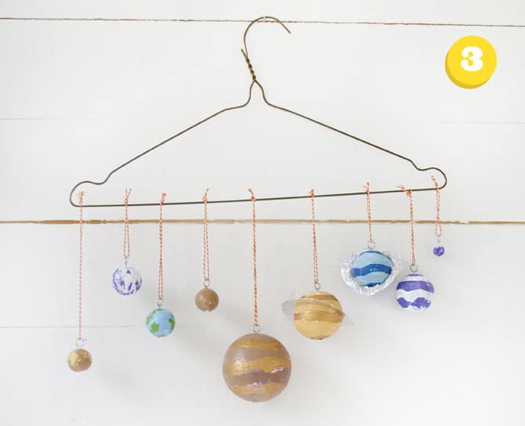
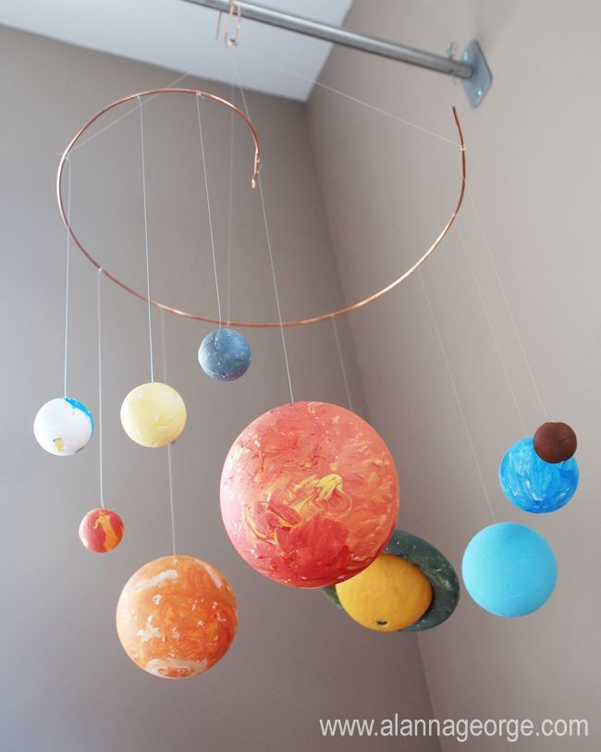
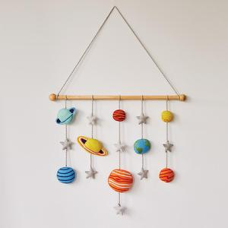

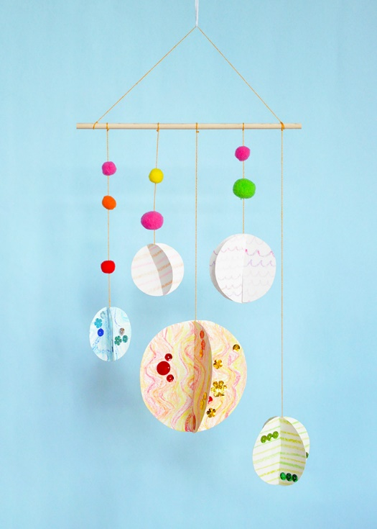
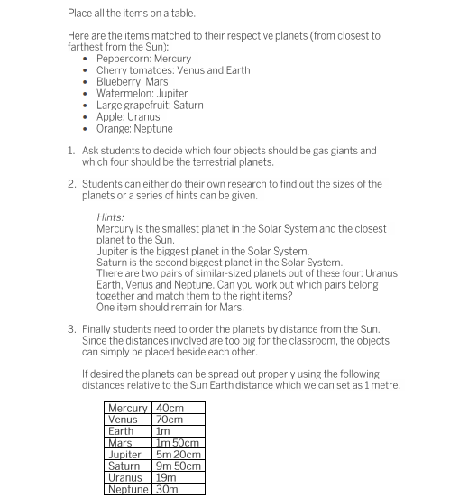
Fruit solar system

